TITLE PAGE

**Table of Contents**

Abstract 1

Introduction 1

Chapter 1 Overview on X-ray detection 1

1.1 Sources of characteristic X-rays 1

1.2 Interaction mechanisms of X-rays with matter 2

1.3 X-ray tube 5

1.4 Inorganic semiconducting materials for X-ray detection 8

Chapter 2 Thin-film X-ray detectors based on organic semiconductors and transition metal dichalcogenides 15

2.1 Device architecture of thin-film X-ray detectors 15

2.2 Electrical characteristics of a Field Effect Transistor (FET) 16

2.2.1 Transfer and output characteristics of a FET 17

2.3 X-ray detection mechanism for thin-film X-ray detectors 20

2.3.1 Charge collection and Photoconductive gain 21

2.4 Sensitivity 23

2.5 Examples of sensitivity of some organic and hybrid semiconductors 25

2.6 Overview on X-ray detectors based on TMTES:PS 26

2.7 Overview on TMDC 31

2.7.1 Electrical properties of monolayer MoS2 32

2.7.2 Fabrication methods of 1L-MoS2 33

2.7.3 Overview on the performance of 1L-MoS2 direct X-ray detectors 37

Chapter 3 Experimental Methods 39

3.1 MoS2 Samples 39

3.1.1 Fabrication methods 39

3.1.2 IV characterization 40

3.1.3 Characterization under X-rays 40

3.2 TMTES:PS Samples 40

3.2.1 Fabrication methods 40

3.2.2 IV characterization 40

3.2.3 Characterization under X-rays 40

Chapter 4 Results for MoS2 samples 40

Chapter 5 Results for TMTES:PS samples 40

Chapter 6 Conclusions 40

Bibliography 40

# Abstract

Here is the abstract…

# Introduction

This is the Introduction part. Here I include the topic of the thesis, brief description of innovative materials, the goal of the thesis – to understand and to compare two performances of the devices with similar structures, the structure of the thesis.

# Overview on X-ray detection

Here I discuss the general X-ray detectors, thin-film transistors for X-ray detection. Don’t be too long here.//

## Sources of characteristic X-rays

If the orbital electrons in an atom are disrupted from their normal configuration by some excitation process, the atom may exist in an excited state for a relatively short period of time. Eventually, there is a natural tendency for the orbital electrons to rearrange themselves to return the atom to its lowest energy state (ground state) within a time which is characteristically in the range of nanoseconds for a solid material. The energy liberated in the transition from the excited state to the ground state takes the form of a *characteristic X-ray photon* whose energy is defined as the difference between the initial and the final states of the atom (Knoll, 2010).

A large number of different physical processes can lead to the population of excited atomic states from which characteristic X-rays originate. The most common mechanisms include:

* **Excitation by radioactive decay**

In the nuclear decay process of electron capture, the nuclear charge is decreased by the capture of an orbital electron, most often a *K*-electron. The resulting atom still has the right number of electrons, but the capture process also creates a vacancy in one of the inner shells. Once this vacancy is subsequently filled, characteristic X-rays are generated (Knoll, 2010).

* **Excitation by external radiation**

This method involves an external source of radiation (X-rays, electrons, α-particles etc.) which strikes the target, creating excited or ionized atoms in the target. Since many of these atoms eventually de-excite to the ground state through the emission of characteristic X-rays, the target can serve as a localized source of these X-rays.

As an example, the incident radiation may consist of X-rays generated in a conventional X-ray tube. The external X-rays may then interact with the atoms of a target through photoelectric absorption; therefore, the excited atoms will emit characteristic X-rays creating their X-ray spectrum. This process is called *X-ray fluorescence*.

Another example of incident radiation could be an external electron beam. In this case the characteristic X-ray spectrum from the target will be contaminated by the continuous *bremsstrahlung* spectrum generated by the deceleration of impinging electrons by their interaction with atomic nuclei. For targets of low atomic number, acceleration potentials of only a few thousand volts are required, which allows to use compact electron sources.

The excitation of a target can also be due to heavy charged particles. The interactions of these particles with the target will give rise to the excited atoms, which will subsequently emit characteristic X-rays. For compact and portable sources, α-particles are often used as incident radiation. As α-particle emitters, 210Po and 244Cm are commonly used (Knoll, 2010).

* **Synchrotron radiation**

Another source of X-rays is performed, when an electron beam is bent into a circular orbit. According to the electromagnetic theory, a fraction of the beam energy is released when the trajectory of the electrons is deflected within a cycle. When extracted from the accelerator in a tangential direction, the radiation appears as an intense and highly directional beam of photons with the energy ranging from visible light (~eV) to X-rays (~104 eV). Although limited to large-scale centralized user facilities, this unique form of electromagnetic radiation is highly because of its high intensity and tunable radiation energy (Knoll, 2010).

## Interaction mechanisms of X-rays with matter

Although a large number of interactions mechanisms between electromagnetic radiation and matter are known, the three major types are usually taken into consideration:

* Photoelectric absorption
* Compton scattering
* Pair production

The common feature of these interactions is partial or complete transfer of the photon energy to an orbital electron, which results in abrupt disappearance of an impinging photon or change of its trajectory by scattering on the electron (Knoll, 2010).

* **Photoelectric absorption**

In the photoelectric absorption process, a photon interacts with an absorber atom, in which the photon passes its energy to an orbital electron and disappears. Instead, an energetic *photoelectron* is ejected by the atom from one of its bound shells. The photoelectron energy is calculated according to the energy conservation law:

|  |  |
| --- | --- |
| $$E_{e^{-}}=hν- E_{b}$$ | 1.1 |

where *Eb* is the binding energy of the photoelectron in its original shell. In addition to the photoelectron, the photoelectron absorption also generates an ionized absorber atom with a vacancy in one of its shells. This vacancy is quickly filled through capture of a free electron or rearrangement of electrons from the other shells. As a result, one or more characteristic X-ray photons may be generated. In most cases these X-rays are reabsorbed close to the original site through photoelectric absorption involving less tightly bound shells. However, their possible escape from radiation detectors can influence their response. In some fraction of the cases, the emission of an Auger electron may substitute fir the characteristic X-ray in carrying away the atomic excitation energy.

The photoelectric absorption process is the predominant type of interaction for X-rays (and gamma-rays) of relatively low energy. The process is also enhanced for absorber materials of high atomic number *Z*. Although there is no single analytic expression for the probability of photoelectric absorption per atom over all ranges of photon energy *­­Eγ* and *Z*, its rough approximation is present:

|  |  |
| --- | --- |
| $$τ ≅const × \frac{Z^{n}}{E_{γ}^{3.5}}$$ where *n* varies between 4 and 5 over gamma-ray energy region (Knoll, 2010). | 1.2 |

* **Compton scattering**

In Compton scattering, the incoming X-ray (or gamma-ray) photon is deflected through an angle *θ* with respect to its original direction (Fig.1) by its interaction with an electron in an absorber atom. The photon transfers a portion of its energy to the electron (assumed to be initially at rest), which is then as a *recoil electron*. Since any angle of scattering is possible, the energy transferred to the electron can vary from zero to a large fraction of the impinging photon energy (Knoll, 2010).

The expression that relates the energy transfer and the scattering angle can be derived by combining the energy and momentum conservation laws:

|  |  |
| --- | --- |
| $$hν^{'}= \frac{hν}{1+ \frac{hν}{m_{0}c^{2}}\left(1-\cos{θ}\right)}$$ | 1.3 |

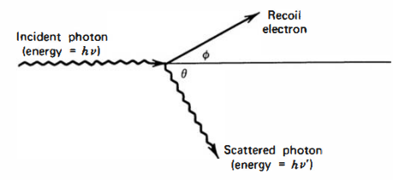

Figure 1.1 Schematic representation of the Compton scattering process (Knoll, 2010).

where *m0c2* is the rest mass energy of the electron (0.511 MeV). The probability of Compton scattering per atom depends on the number of electrons availble as scattering targets and thus, increases linearly with *Z* (Knoll, 2010).

* **Coherent scattering**

In addition to Compton scattering, another type of scattering can occur, when an X-ray (or gamma-ray) photon interacts coherently with all the electrons in an absorber atom. Such *coherent scattering* or *Rayleigh scattering* process neither excites nor ionizes the atom and the scattered photon retains its original energy, although its direction is changed. The probability of Rayleigh scattering is significant only for low photon energies (usually below a few hundred keV for common materials) and in high-*Z* absorbers. Since the average deflection angle decreases with increasing energy, the practical importance of coherent scattering is restricted to low photon energies (Knoll, 2010).

* **Pair production**

If the gamma-ray energy exceeds twice the rest-mass energy of an electron ( $E_{γ}≥1.02$ MeV), the process of pair production becomes energetically possible. In this interaction (which must take place in the Coulomb field of the nucleus), the gamma-ray photon disappears generating an electron-positron pair. All the excess energy goes into kinetic energy shared by the positron and the electron. Since the positron will subsequently annihilate after slowing down in the absorbing medium, two annihilation photons are normally produced as secondary products of the interaction. No precise expression exists for the probability of pair per nucleus, but its magnitude varies approximately as the square of the absorber atomic number (Knoll, 2010).

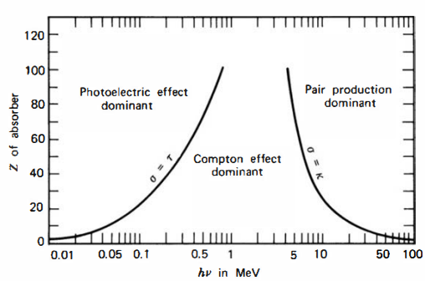

Figure 1.2 Schematic representation of relative probability for different interaction types to occur depending on the *Z* of an absorber atom and on the photon energy *hν*. The lines illustrate the values of *hν* for which the two neighbouring effects are equally probable (Knoll, 2010).

The mean absorbed radiation energy per unit mass of the absorber is the *absorbed dose*. The SI unit of absorbed dose is defined as *gray* (Gy) which is 1 joule per kilogram. The absorbed dose is a reasonable measure of the chemical or physical effects created by a given radiation exposure in an absorbing material (Knoll, 2010).

## X-ray tube

In this section I would like to focus more on a specific device – an X-ray tube, that is broadly used in numerous laboratories and medical departments as a source of X-rays. Since such device was also used during the experimental part of my research, a comprehensive description of the architecture and working principle of an X-ray tube is necessary to have full perception of how the X-ray measurements were performed.

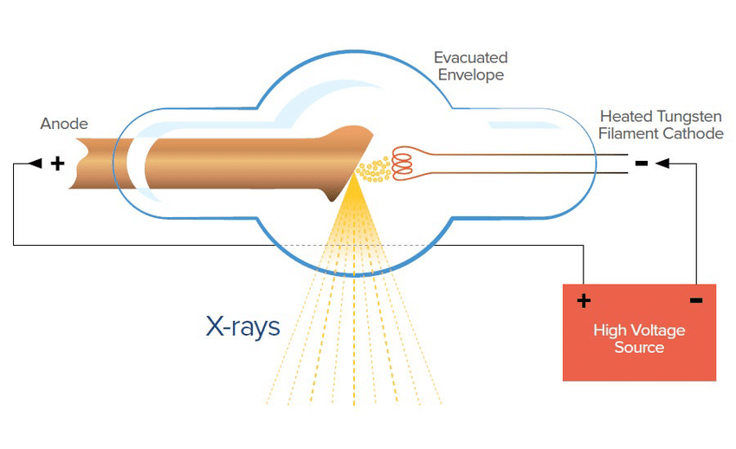

Figure 1.3 Schematic representation of an X-ray tube [1].

As depicted in Fig.1.1, X-rays are generated from the conversion of kinetic energy of electrons into electromagnetic radiation when they become decelerated by interaction with a target material. A high voltage in the range of 20-150 kV is generated between the anode and the cathode inside an X-ray tube. (al. S. P., 2020). The negative pole of the voltage is applied to the cathode, considered as the source of electrons, and the positive pole is applied to the anode, which is the target for the electrons. In order to eject electrons from the cathode, a current through a filament at the cathode is generated by a separate voltage circuit. The thermionic emission effect causes the filament to heat up and expel the electrons into vacuum. Once the electrons are ejected, they are accelerated by the X-ray tube voltage and strikes the anode.

At the anode, electrons start to interact with the atoms of the anode. In particular, the positive nuclei start to attract negatively charged electrons, causing their deflection and deceleration and resulting into emission of *bremsstrahlung* X-ray radiation from the anode in different directions. By providing a small window at different angle in the tube, a collimated beam of X-ray photons is obtained (al. S. P., 2020), (X-ray Production, Tubes, and Generators, n.d.).

The operational characteristics of an X-ray tube include mainly the voltage and the current between the cathode and the anode. The first one allows us to control kinetic energy of the electrons and thus, the energy of generated X-ray photons. The latter is used to operate the number of electrons impinging on the anode and to vary the number of generated photons. Therefore, controlling both these values allows us to establish the desired intensity of X-rays.

Main factors that affect X-ray production efficiency include the kinetic energy of the incident electrons and the atomic number *Z* of the anode (target material). The approximate ratio of radiative energy loss (bremsstrahlung X-rays) to collisional energy loss (excitation of atoms) is the following:

|  |  |
| --- | --- |
| $$\frac{Radiative energy loss}{Collisional energy loss} ≅ \frac{E_{k}Z}{820,0}, for E_{k}≤150 keV$$ | 1.1 |

where *Ek* is the kinetic energy of incident electrons (X-ray Production, Tubes, and Generators, n.d.). Most X-ray tube anodes are made of tungsten, due to its high atomic number (*Z* = 74) and exceptionally high melting point of 3422 ℃ (WOLFMET, 2024) with a correspondingly low rate of evaporation. In mammography, molybdenum (*Z* = 42) and rhodium (*Z*=45) are also used. For instance, if we consider incident electrons with kinetic energy of 100 keV impinging on a tungsten anode, the ratio of radiative to collisional losses will be ≈ 0.9%, meaning that more than 99% of the incident electron energy gets converted to heat. Consequently, the heat dissipation problem is a significant concern for employment of X-ray tubes (X-ray Production, Tubes, and Generators, n.d.), (Technologies, 2024).

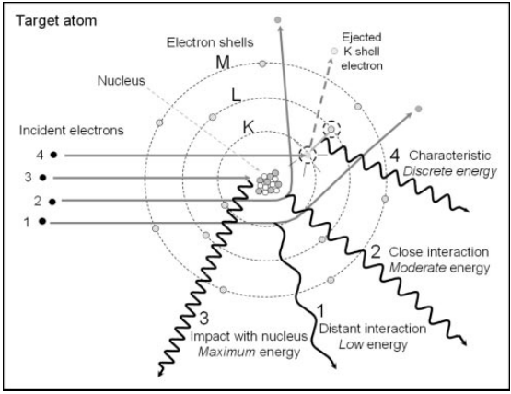Figure 1.4 Mechanisms of formation of bremsstrahlung radiation and characteristic X-rays. Events 1, 3 and 3 demonstrate the interaction of incident electrons in vicinity of the target nucleus producing bremsstrahlung X-rays by the deceleration and deflection of the electrons through Coulomb interaction. Event 4 depicts emission of characteristic X-rays by ejecting of an orbital electron from the K-shell. An unstable vacancy is formed and an outer shell electron occupies the vacancy emitting energy in the form of a characteristic X-ray photon (Seibert, 204).

The X-ray spectrum (Fig.5) output by an X-ray tube consists of discrete characteristic X-rays and continuous bremsstrahlung radiation spectrum with the maximum X-ray energy determined by the potential difference between electrodes. The closer the incident electrons travel to the absorber nucleus, the more intense will be their interaction and the higher will be the emitted photon energy. However, probability of close interaction with the nucleus decreases, thus, decreasing the number of high-energy photons. Therefore, an unfiltered bremsstrahlung radiation energy spectrum is formed the minimum rate at the highest energy and its linear increase with decreasing energy. At the same time low-energy photons are easily attenuated from the beam exiting the X-ray tube window (by Al filters, for example). The measured bremsstrahlung spectrum will have its peak at intermediate energy decreasing to zero at low X-ray energy (Seibert, 204).

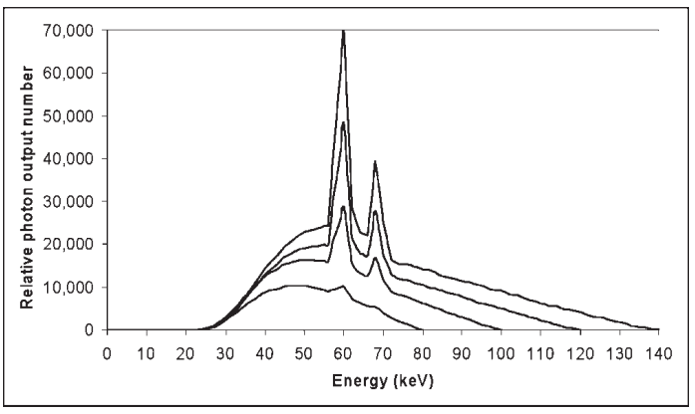

Figure 1.5 Bremsstrahlung and characteristic X-ray energy spectrum for a tungsten anode with the X-ray tube operating at 80, 100, 120 and 140 kV at equal tube current (Seibert, 204).

Discrete characteristic X-ray spectrum is created by the removal of orbital electrons from the target atoms through their interaction with incident electrons. Each electron shell (denoted by K, L, M etc.) have certain biding energies, which for tungsten are 69.5 keV, 11.5 keV and 2.5 keV for the K, L and M shells, respectively. If a highly energetic incident electron has its kinetic energy of at least 69.5 keV, it can potentially eject a K-shell electron leaving a vacancy in the K-shell. Since the atom becomes energetically unstable, another electron for outer shells (L, M, N etc.) will occupy the vacancy in the K-shell (Fig.1.4, event 4), emitting its energy in the form of an X-ray photon. The energy of the photon is defined as the difference in the binding energies of the K-shell and the outer shell. For example, an electron passing from the L-shell to the K-shell will emit a photon with the energy of 69.5-11.5 = 57.0 keV. Since each element has different electron binding energies, the emitted X-ray energies are characteristic of a specific anode element. These characteristic X-rays will create discrete energy spectrum, which shall be added to the continuous bremsstrahlung spectrum. It is worth noting that characteristic X-rays fully depend on the applied voltage, for example, the K-characteristic radiation from a tungsten anode will occur only of the X-ray tube is operated at voltage of ≥ 69.5 kV. As the tube voltage is increased above the minimum value, characteristic X-ray production will also increase its fraction in the X-ray spectrum (Seibert, 204).

## Inorganic semiconducting materials for X-ray detection

The whole multitude of X-ray detection devices might be unified by the principle of creation of charges (free electrons and ions) by passing of X-rays through a material. The most commonly used examples are gas ionization chambers, scintillation counters and semiconductor-based detectors. While the first two types have quite complex configuration, the semiconductor-based devices provide outstanding combination of compact size, high speed, spatial resolution and sensitivity (David Pennicard, 2017). The use of semiconductor materials as radiation detectors can result in a much larger number of carriers for a given incident radiation event that is possible for any other common detector type (Knoll, 2010). The fundamental information carriers are *electron-hole* pairs created by a charged particle or a photon (as primary radiation or its secondary products) in the detector. The motion of generated electrons and holes in an applied electric field generates the basic electrical signal (also called photocurrent) from the semiconductor detector (Knoll, 2010).

Before discussing concrete solid-state X-ray detectors and their architectures, it is good practice to classify the group of semiconductor-based detectors via *direct* and *indirect* detection mechanisms. In the indirect detection, the incident X-ray energy is converted into an electrical signal through a two-step process by using a scintillator material (commonly it is CsI or Gd2O2S (A. Datta, 2020)). In the first step the X-ray radiation impinges on a scintillator, which converts the incident radiation into visible photons. In the second step, a photodiode converts the visible photons into an electrical signal. In the direct detection, the incoming radiation is converted into photocurrent directly in a semiconductor material. Since in our research a semiconductor active channel was used to directly generate photocurrent, from now on our discussion will be focused on the semiconductor-based devices employing the direct detection mode (Laura Basiricò A. C., 2021).

In the next paragraphs I will focus on the X-ray detectors based on inorganic semiconductors (so called *solid-state* detectors), leaving novel thin-film devices in the next chapter. The currently used direct detectors can be subsequently classified into two groups depending on the objective of an X-ray measurement. The first class are *spectroscopic* detectors, which are used to measure the energy of X-ray photons without tracking their trajectory through a material. The second group are *imaging* detectors, which are employed to depict an X-ray image (for example, of a patient’s body). In this case spectroscopic detectors are usually composed of a single element, such as a photodiode or a phototransistor (discussed in detail in the next chapter). Imaging detectors, on the other hand, must be spatially multiplied into millions of pixels to obtain precise X-ray image (David Pennicard, 2017).

To function properly and thus, provide reliable results for any kind of research involving X-rays, a basic direct semiconductor-based X-ray detector should meet the following requirements:

* A small enough band gap that would stimulate the formation of electron-hole pairs and therefore, increase the total photocurrent providing higher signal-to-noise ratio;
* A high atomic number *Z* for better interaction with incident X-ray radiation;
* High resistivity and low leakage current for lower noise current;
* High intrinsic mobility-lifetime *μτ* product to increase the fraction of charge carriers which successfully reach the electrodes before recombination;
* Homogeneous and defect-free medium to enhance charge transport properties;
* Electrodes that would effectively perform charge collection process and would provide a uniform electric field across the medium.

Currently the most commonly used semiconductor-based (or *solid-state*) X-ray detectors are based on inorganic semiconductors, such as silicon, germanium, gallium arsenide, cadmium telluride CdTe and cadmium zink telluride (CZT) (Laura Basiricò A. C., 2021), (David Pennicard, 2017). Based on these materials, different device configurations can be developed. A basic example of an imaging X-ray detector is represented by a strip reverse bias detector used in Particle Physics (Christian W. Fabjan, 2020). Its configuration is composed of numerous small strip-like diodes integrated on the same wafer and connected to its own readout channel. The particle or a photon position is determined by the channel output signal.

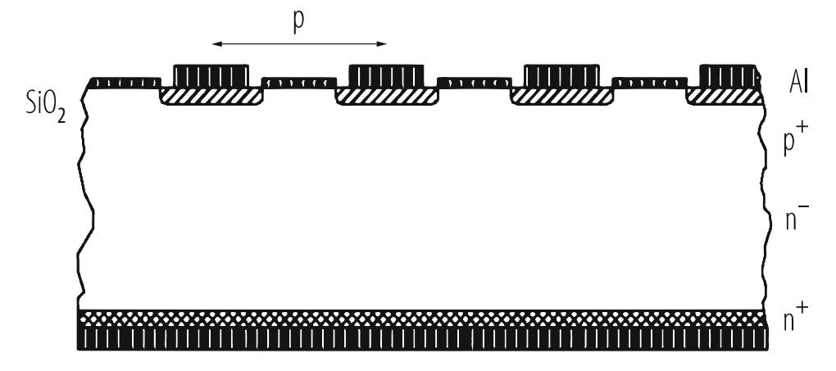

Figure 1.6 Cross section of a Si strip detector built on lightly P-doped (n-) silicon bulk material. Strips are highly B-doped (p+) and the backside is highly P-doped (n+) (Christian W. Fabjan, 2020).

Another conceptually simple, yet powerful, imaging detector architecture is represented by the “hybrid pixel” structure (Fig.1.7). Here a pixelated semiconductor sensor is connected directly with a silicon readout chip with numerous solder particle array, thus, each sensor pixel is connected to a channel of readout electronics on the chip. Such design allows to acquire direct X-ray detection from each individual pixel creating a whole radiation image (David Pennicard, 2017). The hybrid pixel detector structure is of particular concern, because since the readout chip and sensor are separate, the sensor material can be freely chosen from the available range of valid semiconductor materials. It allows us to subsequently focus on commonly used inorganic semiconductors for the sensor pixel array relying on the same detector architecture (Christian W. Fabjan, 2020), (David Pennicard, 2017).

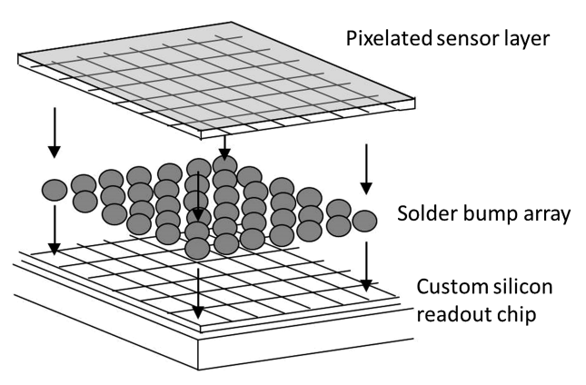

Figure 1.7 Schematic representation of the hybrid pixel detector structure. The pixelated sensore layer is connected to the readout chip with the array of solder bumps. Such structure provides output signal from an individual pixel (David Pennicard, 2017).

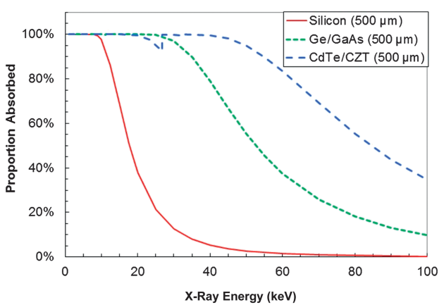

Figure 1.8 Photoelectric X-ray absorption efficiency of common sensor semiconductor materials of 500 µm thickness. The notch in the curve at 30 keV occurs because, while X-ray absorption tends to decrease with increasing photon energy, sudden increase in absorption rate occurs due to photoelectric absorption in the *K*-shell of the atoms (David Pennicard, 2017).

* **Silicon**

Silicon nowadays is the major material used for semiconductor because of verified silicon wafer fabrication, near-perfect crystal homogeneity, robustness and low leakage current in a silicon *pn*-junction. The main disadvantage of the semiconductor is its incapability to efficiently detect high-energy X-ray photons (Fig. 1.8, the red curve). For a 450 µm thick silicon sensor its absorption rate abruptly decreases from 84% to 47% from 12 keV to 17 keV (Silicon Sensors, n.d.). This makes silicon inappropriate for X-ray measurements involving hard X-rays, for example, the study of a material at atomic level (David Pennicard, 2017).

Efficient detection of hard X-ray photons can be achieved by using germanium, gallium arsenide GaAs, cadmium telluride CdTe and cadmium zinc telluride CZT. On the other hand, the crystal homogeneity of compound semiconductors is typically lower than for a pure element, such as Ge or Si. Besides, higher number of defects in compound semiconductors (Matthew D. McCluskey, 2018) might trap additional amount of charge carriers reducing significant part of photocurrent and altering the electric field applied within the semiconductor medium (Neamen, 2012). Consequently, fabrication of large-pixel sized X-ray detectors using compound semiconductors is limited by their less homogeneous structure.

* **Germanium**

Similarly to silicon, germanium is a single-crystal semiconductor, which can be produced using conventional methods, for example, the Czochralski pulling technique (Ben Depuydt, 2006). The main drawback of this semiconductor is its low band gap energy, which is below 0.7 eV at room temperature (300K) (Kittel, 2005). This significantly increases leakage current from thermally generated charge carriers; therefore, an additional cooling system must be integrated. Normally, the temperature is reduced to 77 K through the use of an insulated dewar in which a reservoir of liquid nitrogen is kept in thermal contact with the detector (Knoll, 2010).

The germanium-based detector working principle relies on a *pin*-diode structure (David Pennicard, 2017), in which a *p-* and *n-*regions are separated by an intrinsic region to increase the depletion region (Neamen, 2012). The n+ contact can be formed by diffusion of Li atoms into the wafer. The p+ contact on the opposite site is normally made by B implantation (Vetter, 2007).

Although bulkier and more expensive than silicon-based detectors, the germanium-based detectors, are successfully used in hard X-ray and gamma-ray measurements. Current developments in both sensor technology and readout electronics have led to more compact systems (10-mm-thick Ge layer), demonstrating energy resolutions similar to the silicon detectors, providing an alternative to silicon for a larger energy scale. A large variety of Ge sensor configurations are used for X-ray applications, depending on requirements of a specific experiment. The sensors are generally planar with thickness up to 20 mm with segmentation patterns applied in one or two dimensions (strip or pixel) (David Pennicard, 2017), (Vetter, 2007).

* **Gallium arsenide**

Gallium arsenide (GaAs) has been studied as a radiation detector since the early 1960s. It was the first compound semiconductor operated at room temperature that demonstrated sufficient gamma-ray resolution. At room temperature the band gap energy of GaAs is 1.42 eV (G. Lioliou, 2016), which results in low thermally generated leakage current compared to narrower band gap semiconductors, such as Si and Ge. The average ionization energy of GaAs is 4.3 eV/e-h pair (Knoll, 2010), which indicates that acceptable energy resolution can be provided at room temperature operation. Since the atomic numbers of Ga (*Z=*31) and As (*Z=*33) bracket that of Ge, the expected X-ray and gamma-ray interactions and detection efficiency per unit mass shall be similar to germanium-based sensors. Although GaAs-based detectors output good energy resolution, electric field distortions and charge carrier trapping defects in combination with difficulty of production have prevented the mass realization of bulk GaAs spectroscopic detectors (Knoll, 2010).

Nevertheless, due to relatively wide band gap, GaAs can be used for radiation detection in rough conditions, for example, at high temperatures and at external radiation without the need for cooling system and shielding. GaAs-based detectors are successfully employed in space missions, such as for X-ray fluorescence spectroscopy measurements on Mercury and Jupiter. Another application of GaAs is the electron spectroscopy (G. Lioliou, 2016).

* **Cadmium telluride**

Cadmium telluride (CdTe) is also a high-*Z* semiconductor (*Z=*48 for Cd and 52 for Te) with a sufficiently large band gap energy of 1.52 eV, which makes it appealing material for high-energy X-rays and gamma-rays detection. The probability of photoelectric absorption of gamma-rays per unit pathlength in CdTe is roughly 4-5 times higher than in Ge, and 100 times higher than in Si (Knoll, 2010). On the other hand, poor charge carrier properties and disparity between electrons and holed are typical of CdTe (µeτe = 10-3 cm2V-1 and µhτh = 10-4 cm2V-1). Such low values of mobilities-lifetime products are due to the presence of impurities and defects that act as trapping sites. (L. Abbene S. D., 2014). For example, the mean distance before trapping is on the order of 10 cm for electrons and 10 cm for electrons, which is lower than in Si and Ge (David Pennicard, 2017).

Detector-grade CdTe crystals can be fabricated by first growing polycrystalline CdTe ingots from a Te-rich melt, and then progressively recrystallizing the material by the travelling heater method (THM). Using such approach, single crystal of undoped CdTe can be reliably produced (David Pennicard, 2017). Alternative growth methods may include the Bridgman technique (Knoll, 2010). In order to compensate crystal impurities and defects, CdTe crystals are usually doped with Cl, resulting in high-resistivity *p*-type semiconductor, while the *n*-type crystal is obtained by doping with indium (In) atoms. CdTe detectors are normally fabricated with Schottky contacts using metals with a high work function, such as gold and platinum (Fig.1.9) (L. Abbene S. D., 2014).

CdTe with the *pn-*junction architecture exhibit low leakage current (~nA) even at applied voltage of 100 V. It means that such detectors perform high energy resolution while applying large electric fields to suppress electric field distortions caused by trapping states. However, two main disadvantages limit the success of CdTe sensors as spectroscopic detectors. The first one is called the *polarization* phenomena which represents time instability of a CdTe detector under applied voltage. The polarization phenomena lead to time degradation of the spectroscopic performance of CdTe. One of the methods to minimize the efficiency decrease is the operation of the detector at low temperatures. The second disadvantage of CdTe detectors is the difficulty of fabrication of pixelated structures with the indium electrode for imaging detectors. Aluminum has been found to be appropriate alternative as electrode in pixeled CdTe sensors without increasing leakage current (L. Abbene S. D., 2014).

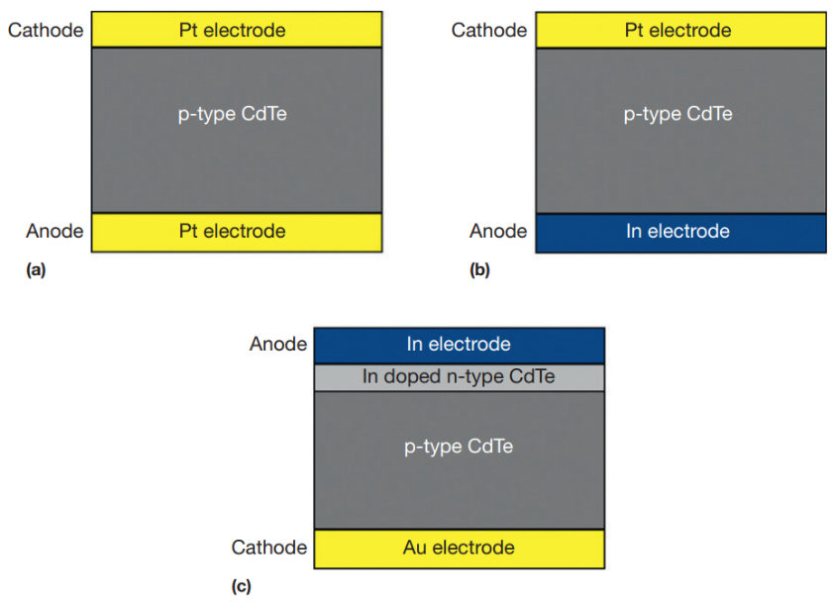

Figure 1.9 Typical CdTe detector configurations: (a) Pt/CdTe/Pt Schottky structure (ohmic contacts); (b) In/CdTe/Pt Schottky structure (rectifying contacts); (c) In/CdTe/Au *pn*-structure (L. Abbene S. D., 2014).

* **Cadmium zinc telluride**

Cadmium zinc telluride (CZT) Cd1-xZnxTe (0<x<0.2) is also considered a good semiconductor for X-ray detection due to its properties, such as: band gap energy of 1.5 eV sufficient to reduce thermally generated noise, thus increasing energy resolution; high atomic number (Cd(48), Zn(30) and Te(52)); absence of negative polarization effect (unlike CdTe); possibility to grow high-resistivity single crystals; relatively good charge transport properties (M. Schieber, 2002). The measured mobilities are 1350 cm2V-1s-1 for electrons and 120 cm2V-1s-1 for holes. Similar to CdTe, the measured lifetime of holes (50-300 ns) is much shorter than that of electrons (100 ns-10 µs) (Knoll, 2010).

Different methods are used for CZT crystal growth. The high-pressure Bridgman technique produces large polycrystalline CZT ingots, which can then be diced to obtain single crystals of a few cubic centimeters. This can provide CZT for spectroscopic detectors, however, imaging detectors usually require larger single-crystal areas. For this purpose, the THM growth technique can be employed (David Pennicard, 2017), (S. Tsigaridas, 2021).

In this section only a few commonly used inorganic semiconducting materials were described. More broad variety shall also include silicon carbide (SiC), mercuric iodide (HgI2), diamond and other crystalline semiconductors. Even though these materials provide satisfactory performance for X-ray detection, they still suffer from numerous limitations, such as inflexibility and difficulty to grow large-scale crystalline structures, which prevents their usage onto flexible widespread substrates. That makes the inorganic solid-state detectors impossible to deposit onto human tissue which could greatly advance radiological measurements.

For this reason, scientific community is actively developing novel semiconducting materials that would provide detection performance comparable to their inorganic analogues, in combination with flexibility, large-scale and low-cost production of semiconductor-based X-ray detectors. The goal of the next chapter is to provide a thorough review on specific semiconductors that are being currently examined as prominent materials for thin-film X-ray detectors.

# Thin-film X-ray detectors based on organic semiconductors and transition metal dichalcogenides

In previous chapter I provided a general overview on X-rays and their interaction with matter. Besides, conventional X-ray detectors based on inorganic semiconductors were briefly discussed. This chapter represents thin-film X-ray detectors, which are based on organic semiconductors and transition metal dichalcogenides (TMDCs). First, I will discuss basic device architectures of the detectors, such as a photodiode and a phototransistor. Since the phototransistor structure was actually used in the experimental part of my research, a detailed overview on a thin-film field effect transistor and its electrical properties will also be provided.

Once the device architecture is presented, an important direct X-ray detection mechanism – photoconductive gain, will be described. This mechanism is of particular interest, since it greatly enhances the sensitivity of low-*Z* organic semiconductors, which makes them comparable alternative to sensors based on inorganic semiconductors. Finally, I will analyze concrete semiconducting materials – 2D MoS2 thin films and a novel organic semiconductor denoted as TMTES blended with polystyrene, which were examined as absorber materials for X-ray detection in my research.

## Device architecture of thin-film X-ray detectors

Nowadays thin-film X-ray detectors constitute the domain that is still quite poorly studied. Different semiconducting materials are being examined to integrate in the X-ray detectors before their further pixelization into large-scale X-ray sensors. For this purpose, in order not to focus on the device configuration but rather on the material properties, basic thin-film photodetector structures are used, in which the semiconductor medium (also called as *absorbing layer* or *active channel*) is operated. Such architectures can be classified as photoconductors, photodiodes and phototransistors. Each architecture has its own different variations depending on the layer and electrode structure. In particular, the geometry of the photodetectors can be either *vertical* or *co-planar* (Laura Basiricò A. C., 2021). In the vertical geometry the absorbing layer is sandwiched between two electrodes, whereas in the co-planar geometry the absorbing layer is directly exposed to the incident radiation. While the vertical geometry is convenient to use in a pixelated matrix, the latter one is easier to fabricate and does not depend on the thickness of the active channel.

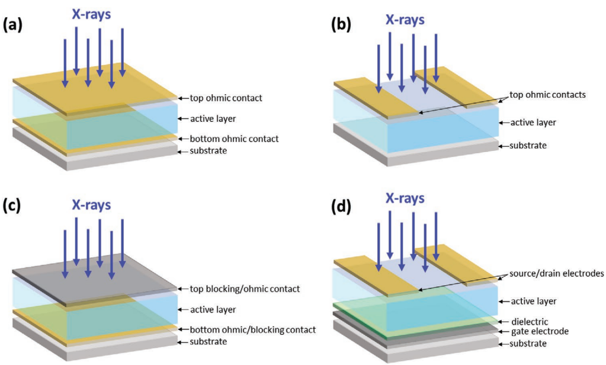

Figure 2.1 Schematics of four typical architectures for direct X-ray detectors: (a) Vertical photoconductor architecture; (b) co-planar photoconductor architecture; (c) photodiode architecture; (d) phototransistor architecture ( (Laura Basiricò A. C., 2021).

A photodiode is vastly used, since its architecture is based on a well-known reverse biased *pn*-junction, which minimizes dark current increasing the signal-to-noise ratio. A phototransistor represents more complex structure, however, it provides more freedom to tune the detector properties and to optimize them for specific conditions. Specifically, by biasing the gate electrode with voltage above the threshold value, it is possible to increase the charge carrier density in the active channel, which will enhance its performance due to so-called *photoconductive gain* mechanism, which will be discussed in the next sections. Furthermore, by applying the gate voltage under its threshold value, a phototransistor will behave as a photodiode performing the *charge separation* mechanism. (Laura Basiricò A. C., 2021).

## Electrical characteristics of a Field Effect Transistor (FET)

Before discussing the X-ray detection mechanisms in the active channel of a phototransistor, it is important to first know the main electrical properties of a field effect transistor (FET), on which a phototransistor is based on. The working principle of a FET lies in the creation of a conductive layer (called the *hole* or *electron inversion layer* for *n-* or *p-*type semiconductor, respectively) between the *source* and *drain* electrodes by applying an electric field between the active channel and the *gate* electrode separated by an insulator (Fig.2.2). Usually, the source electrode is referred to ground, thus, the gate voltage can sometimes be denoted as the gate-source voltage or *VGS*. This is called the *common source configuration* (Luisa Torsi, 2013). The channel length *L* is the distance between the source and drain pads and the channel width *W* is the geometrical width of the channel.

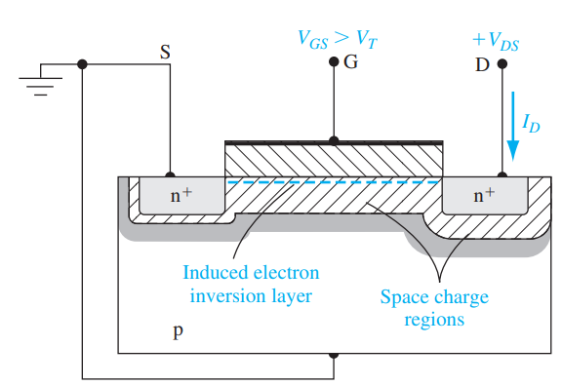

Figure 2.2 Schematics of a FET based on a *p*-type semiconductor. At *VGS­* exceeding certain threshold voltage *Vth*an electron inversion channel is induced and the current of from drain to source flows (Neamen, 2012).

A FET is operated by switching between two modes. The *depletion* mode (OFF state) is the state, in which the inversion layer is absent, thus, the active channel is highly resistive and the current *IDS* between the drain and source is nearly zero (the contribution is only due to small leakage current through the insulator and thermally induced current between drain and source). The *accumulation* (Luisa Torsi, 2013)mode (ON state) is the state, in which the inversion conductive layer is formed, thus, *IDS* starts to increase. The larger |*VGS*| is, the larger the accumulated charge density will be and thus, the larger |*IDS*| will flow between drain and source (Neamen, 2012)**,** (Luisa Torsi, 2013)**.**

### Transfer and output characteristics of a FET

The main electrical characteristics of a FET are extracted from the transfer and output characteristics of the transistor (Fig.2.3).As *VGS* is applied, the charge accumulation near the gate is induced, however, *IDS* does not start to increase until a *threshold* voltage *VGS = Vth* is reached. At this point, the inversion layer is formed and the drain-source current is non-zero. Once the current starts to flow, two regimes are possible depending on the drain-source voltage *VDS*:

* *linear* regime: $\left|V_{DS}\right|≪\left|V_{GS}- V_{th}\right|$
* *saturation* regime: $\left|V_{DS}\right|>\left|V_{GS}- V_{th}\right|$

In linear regime, *IDS* follows the Ohm’s law and is linearly proportional to *VDS* at fixed *VGS*. As $\left|V_{DS}\right|$ increases, the inversion layer becomes more depleted at the drain electrode resulting in the *pinch-off* effect. At this moment a FET is operated in the saturation regime. Fig. 2.3 illustrates basic results of the IV-characterization of a thin-film field-effect transistor based on a *n*-type semiconductor. The data was taken from IV-characterization of a MoS2-based FET. In Fig. 2.3(a), *VGS* is swept from the negative value (-60 V) to the positive (+60 V) and backwards. At the same time *IDS* between drain and source and *IGS* between gate and source are measured. *IGS* provides information on the leakage current through the insulating layer and thus, must be kept close to zero. The output characteristics in Fig. 2.3(c) represents the behaviour of *IDS* while varying *VDS* from 0 to 1 V at different *V­GS* values. It is seen that at higher *VGS* the *pinch-off* effect vanishes and the transistor starts to behave as a resistor, since *IDS* linearly depends on the bias *VDS*.

|  |  |  |
| --- | --- | --- |
| **(a)** | **(b)** | |
| **(c)** | |  |

Figure 2.3 IV characterization of a thin-film field effect transistor based on MoS2 monolayer. (**a**) and (**b**) illustrate the transfer characteristics of the FET in saturation regime (performed at *V­GS* = 1 V); the *VGS* sweep was performed from -60 V to 60 V; red curve in (**a**) depicts the current |*IGS*| between the gate and and the source, which is small leakage current through the insulating layer. The black curve depicts |*IDS*|, which outputs hysteresis at *V*GS ~ -40 V. Such behaviour could be explained by the process of occupying the trapping states in the active channel during the cycle. The red line in (**b**) depicts the linear fit to $\sqrt{I_{DS}}\left(V_{GS}\right)$, which allows to calculate the mobility µ and threshold voltage *Vth*. (**c**) illustratesthe output characteristics of the FET; it is seen that in the saturation regime the *pinch-off* effect occurs only at low values of *VGS*, whereas at higher *VGS* the FET becomes as a resistor with linear *IDS*(*VDS*) behaviour.

In the linear regime, the $\left|I_{DS}\right| \left(V_{DS}\right)$ dependence behave according to the formula:

|  |  |
| --- | --- |
|  | 2.1 |

or, taking into account that :

|  |  |
| --- | --- |
|  | 2.2 |

where *W* and *L* are the width and length of the active channel, respectively, µ is the mobility of the charge carriers in the inversion conductive layer and *Ci* is the dielectric capacitance per unit area. In the saturation regime, |*IDS*| is almost constant (if we omit the channel length modulation effect) and does not depend on *VDS*:

|  |  |
| --- | --- |
|  | 2.3 |

Using the |*IDS*| versus *VGS* behaviour in saturation regime, we can calculate both the mobility µ and threshold voltage *Vth* by plotting $\sqrt{\left|I_{DS}\right|}\left(V_{GS}\right)$:

|  |  |  |
| --- | --- | --- |
| $$\sqrt{I_{DS}}=\sqrt{\frac{WC_{i}µ}{2L}}V_{GS}-\sqrt{\frac{WC_{i}µ}{2L}}V_{th}=AV_{GS}-B$$ | 2.4 | |
| $$µ=\frac{2L}{WC_{i}}A^{2}$$ | 2.5 |
| $$V_{th}=-\frac{B}{A}$$ | 2.6 |
| $$C_{i}= \frac{ε_{o}ε_{r}}{d}$$ | 2.7 |

where *d* is the thickness of the insulating layer, $ε_{r}$ is the relative permittivity of the insulator and $ε_{0}=8.854 ∙ {10}^{-12} F/m$ is the permittivity of vacuum.

Another important electrical parameter of a FET is the *subthreshold swing SS*, which is defined as the inverse of the slope of the $\log\left(\left|I_{DS}\right|\right) \left(V_{GS}\right)$ curve. *SS* measures the gate capability of switching the ON regime at low voltage supply from *VGS*. Small value of *SS* indicated that just a small change of the gate voltage is required to obtain the ON mode. Supposing that in the subthreshold region *IDS* increases exponentially, the subthreshold swing can be calculated according to the formula:

|  |  |
| --- | --- |
|  | 2.8 |

where *CD* is the depletion channel capacitance and *q* is the elementary charge (S.M. Sze, 2007), (al. S. B., 2021).

For an ideal FET, $C_{D}≪C_{i}$ in the subthreshold region and thus, *SS* is ~60 mV/dec at room temperature. However, most thin-film FETs are fabricated on thick SiO2 substrates as insulating layers, with large interface trap density, resulting in large *SS* values (~ a few hundred mV/dec). Although unrealistic in practical applications, also large values of *Ci* can be achieved by using ionic gated transistors, which reduces *SS* close to 60 mV/dec and mobility reaching close to the limitation by phonon scattering, thus, making the ionic transistors efficient to quantitatively characterize the electronic properties of 2D materials. Besides, the interfacial traps between 2D channels and SiO2 also induce unwanted hysteresis in the transfer characteristics of a FET. This can be improved by stacking or encapsulating of the 2D materials with an insulating 2D material, such as hexagonal boron nitride (hBN) (al. S. B., 2021).

The final important electrical parameter of a FET is the ON/OFF ratio, defined as the ratio of the |*IDS*| in the ON-state and OFF-state. This is indicative of switching performance of the device between the conduction regimes and characterizes |*I*DS*|* amplification when the ON-state is induced. Typical values of the ON/OFF ratio for thin-film FETs prepared vary in the range of 106 – 108 (Yun Sun, 2022).

In conclusion, this section sums up the main electrical parameters of a thin-film FET, which are: mobility of charge carriers in the conductive layer µ, threshold voltage *Vth*, subthreshold swing *SS* and ON/OFF ratio. In the experimental part, these parameters were calculated for each phototransistor used for X-ray detection and compared with the values from literature.

## X-ray detection mechanism for thin-film X-ray detectors

As was mentioned in Chapter 1, the main outcome of the interaction of X-ray photons with a semiconductor is the creation of electron-hole pairs by photoelectric absorption or Compton effect. Applying an electric field inside the semiconductor, it is possible to separate the electron-hole pairs and to collect the charges by the respective electrodes thus, measuring photocurrent. The magnitude of the maximum photocurrent can be described by the formula:

|  |  |
| --- | --- |
| $$I_{CC}=Фnq$$ | 2.1 |

where *q* is the elementary charge, *Ф* is the photon absorption rate, *n* is the number of generated electron-hole pairs per absorbed photon. The photon absorption rate *Ф* can be calculated according to the Lambert-Beer equation:

|  |  |
| --- | --- |
| $$Ф= Ф_{0}\left[1-exp⁡\left(-μ_{0}t\right)\right]$$ | 2.2 |

where $µ_{0}= \left(µ/ρ\right) ×ρ_{0}$ is the linear attenuation coefficient, µ/ρ is the mass attenuation coefficient of the absorbing material, *ρ0* is the absorber density, *t* is the interaction length within the material and *Ф0* is the incident photon flux (Laura Basiricò A. C., 2021).

### Charge collection and Photoconductive gain

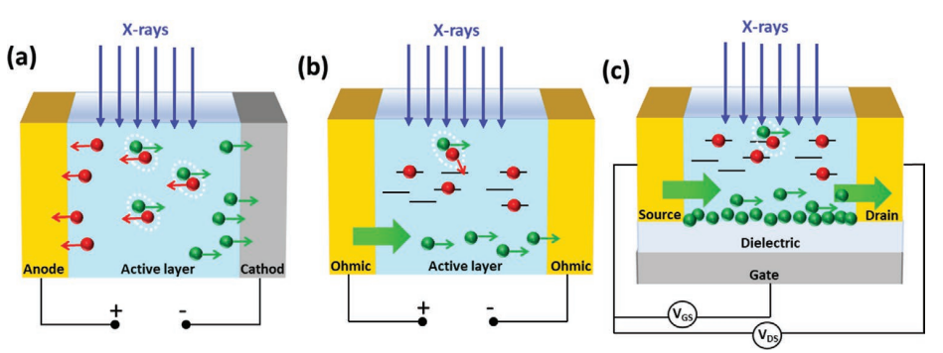

Figure 2.4 Schematics for the direct X-ray detection processes: (**a**) Charge collection in photodiode architecture; (**b**) Photoconductive gain in photoconductor architecture; (**c**) Photoconductive gain in phototransistor architecture (Laura Basiricò A. C., 2021).

For 2D organic semiconductors, the X-ray detection mechanism includes two simultaneous processes (Fig. 2.4). Charge collection was already introduced in Chapter 1 regarding X-ray detectors based on inorganic semiconductors. Similarly for organic semiconductors, when X-ray radiation directly impinges on the active channel, X-ray photons create electron-hole pairs, which are then separated by an applied electric field and thus, additional charge carriers are collected by the electrodes. In order for the charge carriers to reach the collecting electrodes, it is important that the recombination time is sufficiently high and that the density of traps is low. Consequently, charge collection mechanism is dominant for 2D organic semiconductors of high purity and homogeneity (Laura Basiricò A. C., 2021).

The second mechanism introduces *photoconductive gain* (Fig. 2.4 (b,c), Fig. 2.5) and occurs along with the charge collection process. This mechanism amplifies the photogenerated current by the factor *G*, leading to the photo-to-electrical efficiency exceeding 100 % and providing high sensitivity to the X-ray radiation. Photoconductive gain mechanism occurs when radiation-generated, free charge carriers accumulate and pass several times through the semiconductor active channel before recombination sets in. This amplification process is activated by the trapping of minoritycharge carriers during their migration in the semiconductor under the applied field. The factor *G* can be expressed as the ratio between the recombination time *τr* – characteristic of the trap states, and the transit time *τtr* of free moving carriers:

|  |  |
| --- | --- |
| $$G= \frac{τ_{r}}{τ_{tr}}= \frac{μVτ_{r}}{L^{2}}$$ | 2.11 |

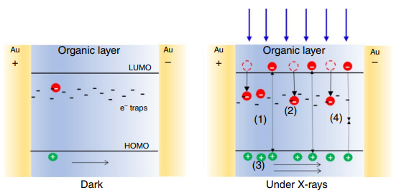where *L* is the channel width, *µ* is the charge carrier mobility and *V* is the applied bias across the active channel. *τr* and *τtr­* represent respectively the time of recombination of the *minority* charge carriers trapped in the active layer, that is, the minority carrier lifetime in a trap, and the transit time of the *majority* carrier to travel across the active channel of the detector (Laura Basiricò A. C., 2021).

Figure 2.5 Schematics of the process of modulation of the conductivity induced by X-rays exposure of TIPS-pentacene thin films: (***left***) in the dark (absence of X-rays) the conductivity is due to the intrinsic carriers; (***right***) under X-ray radiation: (**1**) additional electrons are generated; after generation holes drift along the electric field until they reach the collecting electrode while (**2**) electrons remain trapped in deep trap states withing the organic material. (**3**) To guarantee charge neutrality, holes are continuously emitted from the injecting electrode. AS a consequence, for each electron-hole pair created, more than one hole contributes to the photocurrent leading to the photoconductive gain effect. (**4**) Recombination process takes place, counterbalancing the charge photogeneration in the steady-state (Laura Basiricò A. C., 2016).

The photoconductive gain mechanism has been proposed to interpret high sensitivity in thin-film organic photoconductors based on solution processed bis-(triisopropylsilylethynyl)pentacene (TIPS-pentacene) and derivatives (Laura Basiricò A. C., 2016). As was mentioned in Chapter 1, the cross-section of photoelectric absorption is proportional to $Z^{n}$, where $4<n<5,$ as well as Compton scattering is linearly proportional to *Z*. As a result, materials with high atomic number *Z* perform more efficient interaction with X-ray photons and therefore, possess high sensitivity. On the other hand, organic thin-film X-ray detectors are based on semiconductors with both low atomic number and interaction volume, which leads to extremely low absorption of X-rays.

Approximately 0.0015 % of incident radiation was absorbed by 100 nm thick TIPS-pentacene films. As a result, due to low photon absorption, the obtained photocurrent was calculated to be $\left|I_{CC}^{max}\right|<2$ pA. At the same time, the observed photocurrent was about two orders of magnitude higher than the theoretical value (Laura Basiricò A. C., 2016). It means that some amplification mechanism must be involved.

Since TIPS-pentacene is a *p*-type semiconductor, a different behaviour can be assumed for photogenerated holes and electrons. Holes drift along the active layer reaching the collecting electrode, while electrons get trapped and act as “doping centers”. Due to the ohmic nature of the electrical contacts, charge neutrality is sustained in the active channel. Therefore, for each hole collected by the electrode, another hole is injected in the channel. As a result, for one electron-hole pair created, more than one hole contributes to the X-ray induced photocurrent before recombination takes place. Such amplification phenomenon results in the photoconductive gain (Laura Basiricò A. C., 2021).

Besides photoconductors, phototransistors based on organic semiconductor thin films have also been demonstrated to detect X-rays with high sensitivity due to enhancement of the photoconductive gain effect through the gate polarization (Fig. 2.3 (c)). As mentioned in the previous section, the gate voltage sweeps to progressively switch on the conductive channel in the transistor, that is, towards more negative/positive values of *VGS* for *p-*type/*n*-type semiconductor, the charge density in the transistor’s active channel increases, leading to the enhancement of minority carriers accumulation and majority carriers conduction. Furthermore, majority charge carriers are more easily injected from the electrodes due to the lowering of the contact resistance. Therefore, in over-threshold condition *τtr* decreases, which leads to the increase of the photoconductive gain *G* (Laura Basiricò A. C., 2021).

## Sensitivity

As was discussed in previous chapters, an X-ray detector’s efficiency performance is determined by numerous parameters, such as the atomic number *Z* of the semiconductor, its band gap energy and bulk resistivity. Nonetheless, from a technological standpoint, our attention below centers on the *sensitivity* of an active channel of a phototransistor. This parameter will further serve as the benchmark for evaluation of the efficiency of our device.

The sensitivity of an X-ray detector is denoted by *S* and characterizes the ability of a detector to react to certain amount of X-ray radiation by generating photocurrent in the active channel. Although there are several formulas describing sensitivity, the basic method to calculate *S* is based on the dependence of photocurrent |*IPH*| on dose rate *DR*. First, one has to measure the photocurrent created by incident X-ray radiation with certain dose rate. Typically, the photocurrent is the difference between the current *IX-ray* across the active channel during X-ray radiation and the current *Idark*, when the radiation is absent. The entity of dose rate is the amount of X-ray radiation energy per unit mass of the absorber material and per unit second of irradiation. Then, once several values of |*IPH*| at different *DR* are obtained, the resulting plot is fitted with linear function. Finally, sensitivity is defined as the slope, or equally, the derivative, of the linear plot (Laura Basiricò A. C., 2021):

|  |  |
| --- | --- |
|  | 2.12 |

However, often it is more convenient to study the sensitivity of a thin-film detector without being tied to the geometry of the active channel and with focusing only of the semiconductor properties. In this case, it is common to calculate sensitivity per unit area or per unit volume of the active channel:

|  |  |
| --- | --- |
|  | 2.13 |

or:

|  |  |
| --- | --- |
|  | 2.14 |

where *A* and *V* are the respectively area and the volume of the active channel. The SI unit of photocurrent is $\left[I_{PH}\right]=A= C/s$, the SI unit of dose rate is $\left[DR\right]= {Gy}/s$, therefore the SI unit of sensitivity is $\left[S\right]= \frac{\left[I_{PH}\right]}{\left[DR\right]}= \frac{C}{Gy}$. For the case of sensitivity per unit area or unit volume, the unit is usually expressed as: $\left[\frac{S}{Area}\right]= \frac{C}{Gy∙{cm}^{2}}$, $\left[\frac{S}{Volume}\right]= \frac{C}{Gy∙{cm}^{3}}$.

It is mentioning that dose rate is inversely proportional to the square of distance from an X-ray source:

|  |  |
| --- | --- |
| $$DR= \frac{const}{r^{2}}$$ | 2.15 |

Consequently, while using an X-ray source for measuring the sensitivity of a thin-film detector, the dose rate must be properly calibrated accordingly to the distance between the X-ray source and the device. For example, if one knows the dose rate *DR1* at distance *r1* from the source, the dose rate *DR2* at distance *r2* can be calculated as follows:

|  |  |
| --- | --- |
| $${DR}_{2}= {DR}_{1}∙ {\left(\frac{r_{1}}{r_{2}}\right)}^{2}$$ | 2.16 |
|  |  |

## Examples of sensitivity of some organic and hybrid semiconductors

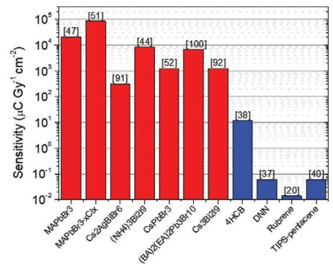

Figure 2.6 Comparison of top sensitivity for organic and perovskite-based detectors (Laura Basiricò A. C., 2021).

To estimate the performance of different thin-film direct X-ray detectors, from large multitude of organic and hybrid semiconductors we will regard several 2D materials that are currently under investigation. When it comes to thin-film photovoltaics, among the most prominent are perovskite-based X-ray detectors. Recent studies on such devices have been primarily concentrated on identifying technological approaches to improve film thickness, specifically radiation absorption, at the same time ensuring a sufficient µτ product to uphold optimal charge collection efficiency. The highest sensitivity reported for a perovskite-based detector was found to be 1.22 × 105 µC/(Gy·cm2) for a 800 µm thick MAPbI3 wafer fabricated by a heating-assisted press method (Laura Basiricò A. C., 2021).

Another example of a direct thin-film organic X-ray detector is based on bis-(triisopropylsilylethynyl)pentacene (TIPS-pentacene) with the photoconductor architecture. The device was fabricated while drop casting onto flexible poly(ethyleneterephtalate) (PET) substrate. While biasing the X-ray detector with 0.2 V, the highest sensitivity value was evaluated as 77 × 103 nC/(mGy·cm3) (Laura Basiricò A. C., 2016). On the other hand, in (Inés Temiño, 2020), TIPS-pentacene organic field effect transistors (OFETs) were used as X-ray detectors and exhibited the record sensitivity of 1.3 × 104 µC/(Gy × cm2) while being biased at *VSD* = -20 V and *VGS* = -15 V exposed to a dose rate of 53 mGy/s.

Regarding hybrid semiconductors, in (H.M. Thirimanne, 2018) a thin-film direct X-ray detector with the photodiode architecture was made of hybrid semiconductor consisting of organic bulk heterojunction (BHJ) of poly(3-hexylthiophene-2,5-diyl) (P3HT) and [6,6]-Phenyl C71­ butyric acid methyl ester (PC70BM), with the nanoparticles (NPs) of Bi2O3. The X-ray source was a medical linear accelerator. The sensitivity of such devices was estimated to be 1712 µC/(mGy × cm3) under 50kV soft X-rays and ~30 and 58 µC/(mGy × cm3) under 6 and 15 MV hard X-rays. The sensitivities were obtained at -10 V applied to the photodiode.

## Overview on X-ray detectors based on TMTES:PS

In the previous work regarding X-ray detectors in the form of *p*-type OFETs based on TIPS-pentacene blended with polysterene (PS), the devices already demonstrated excellent sensitivity comparable to the perovskite-based detectors. The organic semiconductor (OSC) thin films were fabricated by the solution shearing technique of high processing capacity, known as the *bar-assisted meniscus shearing* (BAMS) method, which outputs large scale crystalline films. During the analysis, it was concluded that the organic-based detector efficiency strongly depends on the grain size and grain boundaries and also on the mobility of the active channel. Regarding the former in combination with photoconductive gain mechanism, films with smaller crystal domains exhibited better performance due to increase of the density of traps for minority charge carriers (in case of TIPS-pentacene electrons are the minority carriers), which enhanced photoconductive gain and thus, sensitivity. At the same time, the active channel mobility can be improved by employing the OSCs with crystal structure containing strong intermolecular electron coupling and by reducing the density of traps for the majority charge carriers (for TIPS-pentacene, holes are the majority carriers). The density can be decreased by using OSC:PS blends, as thin film deposition induces vertical phase separation, creating a lower PS layer that passivates the interfacial majority carriers traps and again, enhances the majority charge carrier mobility also contributing to the sensitivity (Laura Basiricò A. C., 2016), (Adriàn Tamayo, 2022).

In an effort to enhance the performance of the X-ray detector, the focus shifted towards producing OFETs with improved hole transport. For this purpose, a similar *p-*type OSC 1,4,8,11-tetramethyl-6,13-triethylsilylethynyl pentacene (TMTES) blended with PS was analyzed. The molecular structure of TMTES closely resembles that of TIPS-pentacene. Nevertheless, thin films of TMTES deposited with the BAMS method resulted in completely different crystal packing arrangement, characterized by a herringbone packing motif. As a result, the density of traps was reduced due to the PS layer, which led to the enhancement of the mobility up to 2.5 cm2/(V·s). The new device performed outstanding sensitivity of (4.5 ± 0.05) × 1010 µC/(Gy · cm3), which exceeded that of TIPS-pentacene detector by one order of magnitude. Consequently, the sensitivity of the TMTES:PS device was reported to be the highest of a fully organic X-ray detector (Adriàn Tamayo, 2022).

|  |  |
| --- | --- |
| **(a)** | **(b)** |
|  |  |

Figure 2.7 (**a**) Molecular structure of TMTES and PS; (**b**) Schematics of the BAMS technique for the deposition of the active layer (Laura Basiricò A. C., 2016).

Since the experimental part of our research regarding TMTES:PS X-ray detectors will be also compared to the results from this work (Laura Basiricò A. C., 2016), it is important to transmit more in detail the conditions in which the TMTES:PS based devices were characterized. Ambient conditions were sustained during the thin film deposition by BAMS. It was found that the use of combination of small molecule OSCs blended with insulating polymers can ease the solution processability resulting in thin films with improved electrical performance and device stability. The selection of PS as a binding polymer was based on its low relative permittivity, good solubility in organic solvents, cost-effectiveness and its weak interaction with organic semiconductors. Different ratios between TMTES and PS were considered during the TMTES:PS thin film preparation. As a result, the finest thin film properties were attained by using a 2:1 ratio of TMTES to PS (PS with a molecular weight of 280 KDa). The solution was deposited at 105 ℃ on Si/SiO2 substrates with interdigitated Au electrodes treated with a self-assembled monolayer of 2,3,4,5,6-pentafluorobenzenethiol (PFBT). The thickness of the TMTES:PS films was estimated as 32±7 nm (Adriàn Tamayo, 2022).

In order to view the chemical map of the TMTES:PS thin films, Time-of-Flight Secondary Ion Mass Spectroscopy (ToF-SIMS) was applied for both horizontal and vertical dimensions. As a result, no horizontal phase separation was observed. At the same time, during vertical profiling, the signal from TMTES notably decreased, whereas the PS ion signal increased, exhibiting larger concentration of PS molecules closer to the SiO­2 substrate (Adriàn Tamayo, 2022).

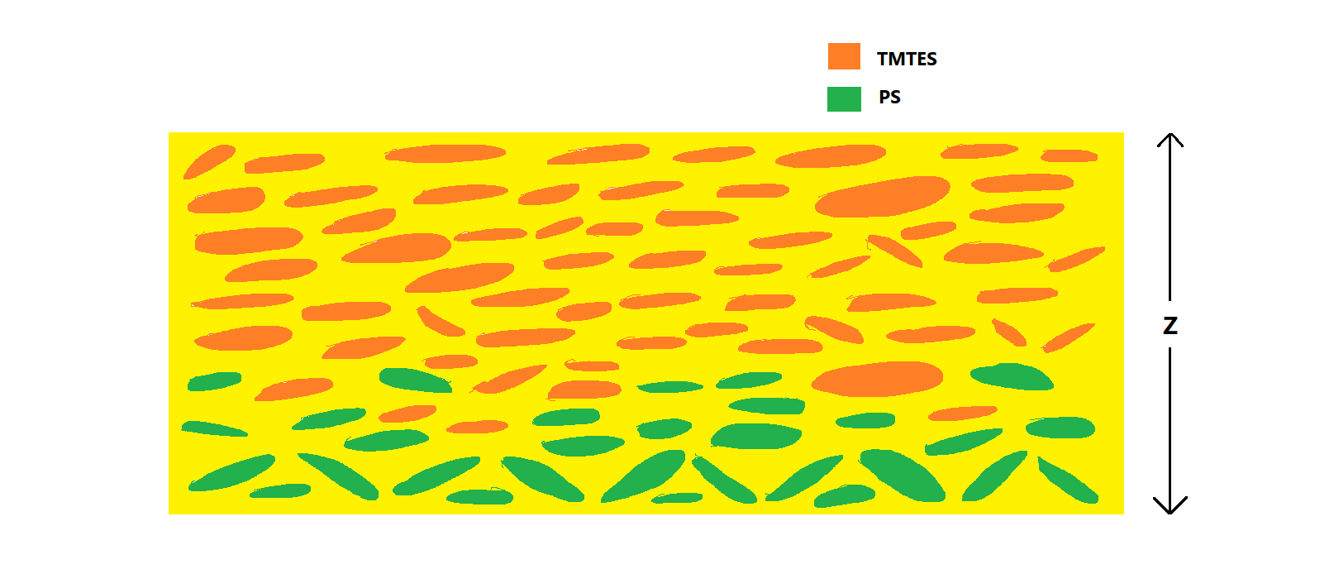

Figure 2.8 Vertical cross-section of a TMTES:PS thin film. PS molecules (green) are concentrated at the bottom, while TMTES (orange) are located in the top part of the film.

Both TMTES and TMTES:PS thin films underwent electrical characterization under ambient conditions as active layers in OFETs. As a result, OFETs with TMTES:PS as the active layer exhibited better performance compared to those based solely on TMTES. The former operated within a lower voltage window of 5 V and displayed excellent electrical characteristics with reduced hysteresis and significantly less dependence of the mobility on *VGS*. The threshold voltage *VTH* for TMTES:PS based devices approached 0 V (ranging from -0.5 to -1 V), providing further evidence of benefit of using PS together with the semiconductor. Additionally, the density of traps for the majority charge carriers (in this case holes), was estimated from the sub-threshold slope to be (3.9±0.9) × 1011 e/(V·cm2), which is one order of magnitude lower than that for the TMTES films (~1012 e/(V·cm2)). This observation confirms that adding the insulting PS to TMTES compound results in reduction of interfacial traps for majority charge carriers (Adriàn Tamayo, 2022).

Finally, detectors based on TMTES:PS exhibited a notably high average mobility of 2.6 ± 0.6 cm2/(V·s) with the maximum value of 3.1 cm2/(V·s). Such mobility values in combination with previously mentioned electrical characteristics of TMTES:PS thin films rank among the best reported for this semiconductor. It is noteworthy that the films were fabricated using a low-cost and high throughput BAMS technique which is a significant advantage in terms of mass production (Adriàn Tamayo, 2022).

Such remarkable electrical properties of TMTES:PS based OFETs deposited by the BAMS technique allowed to presume these devices to perform efficiently as X-ray detectors. For this purpose, the sensitivity of the TMTES:PS based OFETs was measured under X-ray radiation in the form of periodic pulses (on/off beam switches) of different dose rate. During the X-ray exposure, the

|  |  |  |
| --- | --- | --- |
| **(a)** | **(b)** | |
| **(c)** | |  |

Figure 2.9 Electrical and X-ray performance of the TMTES:PS based OFETs. (**a**) Transfer characteristics in saturation regime; (**b**) output characteristics; (**c**) X-ray induced photocurrent as a function of the dose rate. The sensitivity is calculated as the slope of the linear fit of the experimental points (Adriàn Tamayo, 2022).

devices biased to operate in saturation regime (*VDS* = -15 V and *VGS* = -20 V). The current *IDS* flowing between the source and drain was measured during the on/off beam switching cycles. The photocurrent was measured as the difference between the values of *IDS* during X-ray radiation and in the dark. The resulting signal was amplified by the photoconductive gain effect (discussed in previous sections), which occurs due to minority carriers traps and which allows low-Z thin-film organic semiconductors to perform high sensitivity. According to its definition, the sensitivity of TMTES:PS based OFETs was calculated as the slope of the linear fit to the dependence of the photocurrent |*IPH*| on the X-ray dose rate. Resultantly, the sensitivity of the TMTES:PS based detectors was estimated as (4.10 ± 0.05) × 1010 µC/(Gy·cm3). Such value was considered as the highest sensitivity value documented for an X-ray detector based on fully organic active layer, which also surpassed the sensitivity of the majority of the sensors based on perovskite films. Additional advantage of the TMTES:PS based detectors in comparison with those based on lead-halide perovskites, is that it fully matches human tissue equivalent absorbance of ionizing radiation. This feature paves the way for TMTES:PS based X-ray imaging detectors in numerous medical dosimetry applications (Adriàn Tamayo, 2022).

Such remarkable sensitivity of TMTES:PS based X-ray detectors in combination with their outstanding electrical properties and tissue-like absorbing behaviour inevitably consider further research into this new technology. For this purpose, the second part of my experimental study includes both electrical characterization and performance under radiation of OFETs with the active layer made of TMTES:PS with different ratio of TMTES to PS. The goal of my laboratory study is to trace any dependence of the device performance on the TMTES:PS ratio and to provide scrupulous and comprehensive analysis on this tendency. The most part of the study has already been conducted by my colleague Alessandro Galeazzi, therefore, his results will be directly connected to my research. Additionally, it is noteworthy to mention that the TMTES:PS based OFETs were equally fabricated at the Institute of Materials Science of Barcelona (ICMAB) in the research group of Dr. Marta Mas-Torrent. Therefore, the information of the materials and device fabrication, which was referenced in this overview, shall be duplicated in the Chapter 3. Nevertheless, such repetitiveness should not only provide consistency in the persistent and comprehensive research on TMTES:PS based X-ray detectors, but also introduce new details on their structure and production procedure.

## Overview on TMDC

Alongside with detectors based on fully organic semiconductors, recently great attention has been drawn by 2D transition metal dichalcogenides (TMDCs) in the thin-film optoelectronics field as prominent materials for *in vivo* radiation monitoring applications. TMDCs compose a large class of inorganic layered materials, which perform a variety of different electronic properties from semiconductivity to superconductivity, which makes TMDCs quite perspective materials for nanoelectronics, thin-film flexible electronics and power conversion domain (Arun Kumar Singh, 2018), (Alberto Taffelli, 2023).

TMDCs have the **MX2** stoichiometry, where M stands for a transition metal (M = Mo, W, Ti, Nb etc.) and X means a chalcogen (X = S, Se, Te etc.). The general structure of a TMDC represents a sandwich-layer structure, in which a layer of transition metal atoms is placed between two layers of hexagonally packed chalcogen atoms, thus, forming a periodic **X-M-X** layer order (Fig. 2.6). The bulk crystal of TMDC consists of the X-M-X layers bound together with weak van der Waals forces. (Arun Kumar Singh, 2018), (Saju Joseph, 2023).

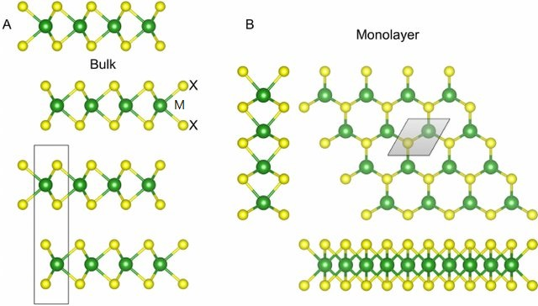

Figure 2.10 The atomic structure of TMDCs of 2H polytype. M stands for a transition metal, X signifies chalcogenide). Bulk (**A**) and monolayer (**B**) structures are demonstrated with their unit cells. Layers are bound together by van der Waals forces (Heine, 2015).

Among the diverse multitude of different TMDC compounds, our attention shall now focus on **MoS2**, which is particularly attractive for the field of thin-film electronics. The crystal structure of MoS2 can be categorized into four polytypes, depending on the atomic stacking configurations: 1H, 1T, 2H and 3R (Fig. 2.7). The 2H-polytype is thermodynamically favoured by naturally occurring bulk MoS2 and represents the S-Mo-S layers stacked in hexagonal symmetry (from the top view) with each Mo atom covalently bonded with neighbouring six S atoms (Arun Kumar Singh, 2018). In contrast, in the 1T-polytype, which is metastable (Mattevi, 2020), forms a tetragonal symmetry with an octahedral metal coordination, as the layers are offset from each other. The 2H-MoS2 structure exhibits semiconducting properties, whereas the 1T-MoS2 is metallic. The metastable 1T-MoS2 can be readily transformed to 2H phase via intralayer atomic gliding under specific conditions (Arun Kumar Singh, 2018) (1T-Phase Transition Metal Dichalcogenides (MoS2, 2017).

### Electrical properties of monolayer MoS2

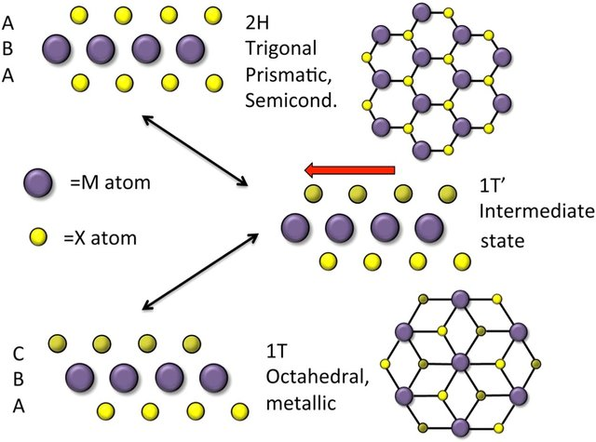

Figure 2.11 Schematics of the 2H- and 1T-polytypes of MoS2. the 2H phase is trigonal prismatic and the material behaves as a semiconductor. The 1T phase is octahedral and the material is metallic. The 1T’ phase represents an intermediate state (Adam L. Friedman, 2017).

Recent progress in the characterization of nanoscale materials has created new possibilities to thoroughly study the electrical and optical properties of 2D TMDCs by means of computational modelling tools. Utilizing the first-principle density functional theory (DFT), it has become possible to calculate the band structure of MoS2 both as bulk and as a monolayer (Fig. 2.8). As a result, it was

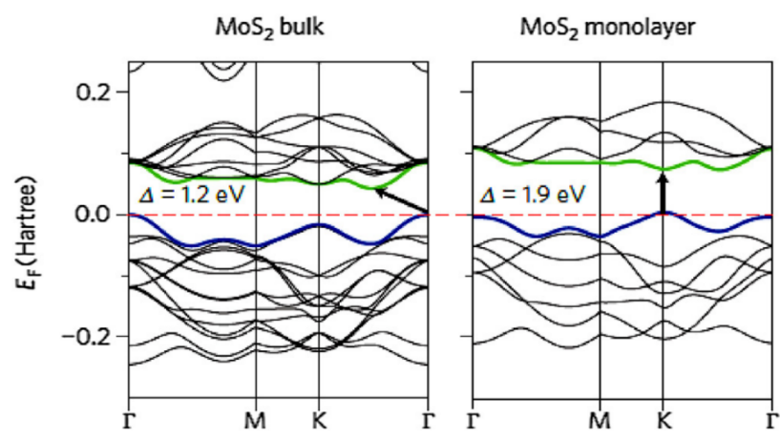

Figure 2.12 Band structures for bulk and monolayer MoS2 calculated with the first-principles DFT. The pointer indicates the band gap (direct for monolayer and indirect for the bulk), the red dashed lines indicate the Fermi level. The top of the valence band and the bottom of the conduction band are highlighted in blue and green, respectively (Arun Kumar Singh, 2018).

revealed that the MoS2 crystal possesses an indirect band gap of 1.9 eV at the Г-point. While decreasing the number of layers for MoS2, the band gap energy gradually decreases, thus, in a monolayer MoS2 the band gap is direct has the value of 1.2 eV.

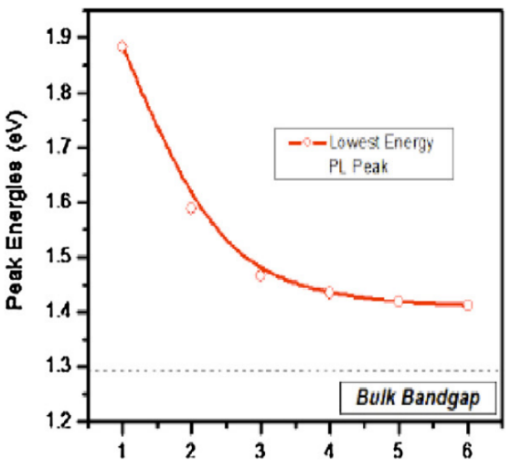

Figure 2.13 Band gap energy of MoS2 as a function of layers. the dashed line shows the (indirect) band gap energy of bulk MoS2 (Arun Kumar Singh, 2018).

The semiconductor-like behaviour of MoS2 subsequently led to its testing in FETs as an active channel. As a result, recent research has evaluated the main electrical parameters of a top-gate FET based on monolayer MoS2 in ambient conditions. The device performed the *n*-type behaviour with the average mobility exceeding 200 cm2/(V·s), the ON/OFF ratio of ~108 and the subthreshold swing (*SS*) of 74 mV/dec (Arun Kumar Singh, 2018). Such excellent electrical properties in combination with suitable mechanical flexibility eventually introduce monolayer MoS2 (1L-MoS2) as a prominent semiconductor for usage in thin-film flexible electronics including also detectors for ionizing radiation.

Another example of employing MoS2 thin films in FETs is presented in (Ji Heon Kim, 2016). In this research Thin MoS2 flakes with different number of layers (*Nlayer* = 1, 3 and 6) were fabricated by mechanical exfoliation (see below) and then transferred onto highly *n*-doped silicon wafers with SiO2 dielectric on top. The IV-characterization was performed in ambient conditions. As a result, the average subthreshold swing *SS* was found to be 0.92, 0.92 and 1.41 V/dec for 1L-, 3L- and 6L-MoS2, respectively. The ON/OFF ratio was calculated as ~107 for all the transistors. Finally, the field-effect electron mobility *µ* increased with increasing of *Nlayer* ranging from ~10 to 18 cm2/(V·s) (Ji Heon Kim, 2016).

Performance of monolayer MoS2 in FETs was also verified in (Zongyou Yin, 2011). In this work 1L-MoS2 nanosheet was equally fabricated by mechanical exfoliation and deposited onto a Si wafer. According to the results, the ON/OFF ratio was found to be ~ 103, whereas the calculated field-effect mobility of was 0.11 cm2/(V·s).

|  |  |
| --- | --- |
|  | **(c)** |

Figure 2.14 (**a**) Schematic cross-section of a MoS2 thin-film transistor with bottom-gate architecture; (**b**) optical micrograph of the representative MoS2 transistor; (**c**) field-effect mobility of the MoS2 FET as a function of Nlayer (Ji Heon Kim, 2016).

### Fabrication methods of 1L-MoS2

Before discussing the role of 1L-MoS2 as an active layer in X-ray detector, it is of good practice to first regard different fabrication methods of the monolayer, which typically include mechanical exfoliation, chemical vapour deposition, RF sputtering and various liquid phase preparations. The mechanical exfoliation (ME) technology involves the “peeling” or “cleaving” of bulk crystals by using an adhesive tape or rubbing the crystals against a solid surface. as a top-down technique, ME has been widely applied to produce single- or few-layer MoS2 (and TMDCs in general) thin films from their bulk counterparts. As previously mentioned, in TMDCs layers are bonded together along the vertical axis with weak van der Waals forces, which allows to perform easy exfoliation due to weak interlayer forces. Consequently, the ME technique can be used to produce a few-layer MoS2 film with thickness of approximately 3-10 nm. Nevertheless, while ME enables the fabrication of clean and high-quality MoS2 thin films, this method is limited to research purposes only is not applicable to large-scale production (Arun Kumar Singh, 2018).

* **Exfoliation method**

Beside the mechanical method, a thermally activated metal-mediated exfoliation method is available. The fundamental concept behind this exfoliation technique lies in the cleaving a parent MoS2 crystal onto a metal surface by overcoming van der Waals interlayer forces, such that the bottom layer will remain on the surface through MoS2-metal interaction. Gold (Au) has proven to be highly effective in exfoliating layered materials including TMDCs by gold affinity towards chalcogen-based compounds (Max Heyl E. J.-K., 2022). The illustrated process of thermally activated metal-mediated process is depicted in Fig.2.10, utilizing MoS2 as the test material. The exfoliation initiates by exposing MoS2 and Au surfaces, bringing them together on a hotplate. The process concludes by peeling off the MoS2 parent crystal, resulting in large-area MoS2 layers exfoliated onto gold. The annealing step is normally conducted at 200 ℃, while performing output of worse quality at lower temperatures (Max Heyl D. B.-K., 2020).

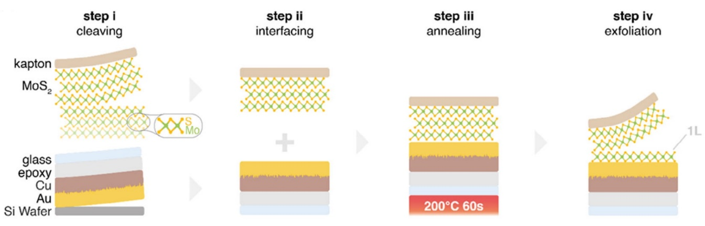

Figure 2.14 Schematic illustration of thermally activated metal-mediated exfoliation process of a MoS2 thin film on a Au surface (Max Heyl D. B.-K., 2020).

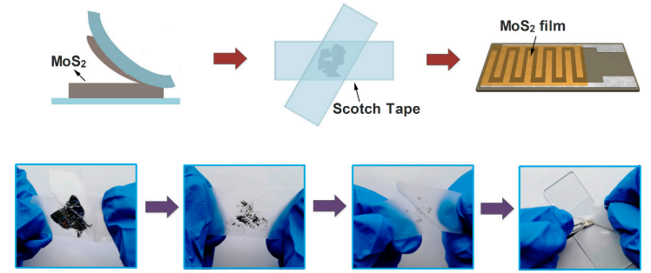

Figure 2.15 Schematic representation of the fabrication of MoS2 thin films by mechanical exfoliation (with the use of a scotch tape) (Wenli Li, 2019).

Often the resulting MoS­2 thin film is produced in the form of flakes with the area of a few mm2, as it was in my experimental research. For example, I was given MoS2-based phototransistors with the active channel in the form of a flake with the drain and source electrodes attached to it. And basically, it would not disturb the characterization of the detectors based on such flakes in laboratory conditions. However, because of weak attachment between the flake and a substrate, the mechanical exfoliation imposes a risk to lose or damage MoS2 flakes while moving the substrate or rotating it during an experiment. Therefore, it is vital to treat the samples with ME-fabricated MoS2 nanosheets with great carefulness.

* **Chemical Vapour Deposition (CVD) method**

As we see, although mechanical exfoliation represents quite reliable and easy-to-perform method of TMDC thin film deposition, it loses all its potential when it comes to mass production and real-world applications. In this, case, an alternative deposition technique should be used to output large-scale TMDCs nanosheets. Chemical vapour deposition (CVD) stands out as a good candidate for this purpose, as it has been widely adopted for the mass production of devices based on III-V and III-N materials. Despite its apparent simplicity, this technique continues to be one of the most extensively utilized methods for synthesizing thin films of TMDCs and in particularly, of MoS2. Numerous positive reviews on the applying of the CVD method relatively to MoS2 have already been published, which promotes the further research on this fabrication technique (Luca Seravalli, 2021).

The working principle of CVD is depicted on Fig. 2.16. Precursors, consisting of either only S or both S and Mo, are delivered in gaseous form to a substrate, which is maintained at high temperature. At this temperature, the necessary chemical mechanisms for MoS2 deposition onto the substrate takes place. While the substrate is typically held in horizontal position in most reports, it usually suffers from the film thickness gradient along the direction of the flow, leading to non-uniform deposition and challenges in determining the growth parameters of the film. To overcome this issue, the development of vertical CVD reactors takes place, since this configuration allows for easier control and homogeneity of temperature and precursor throughout the substrate surface (Luca Seravalli, 2021).

A common procedure starts with the reduction of contamination from external air and O2 within the CVD tube by purging the system with inert gas multiple times before initiating the growth process. A typical CVD process depends on the phase form of the used precursors (solid, liquid or gaseous) and can be roughly divided in to the following steps: (1) converting the precursors (Mo and S) into a gaseous state and absorbing them into the inert carrier gas by evaporation or as sublimation powders; (2) transporting the reactive species using the carrier gas to reach the substrate; (3) Diffusing the precursors toward the substrate surface; (4) Adsorption of the precursors at the surface, leading to the synthesis of the MoS2 thin film (Luca Seravalli, 2021).

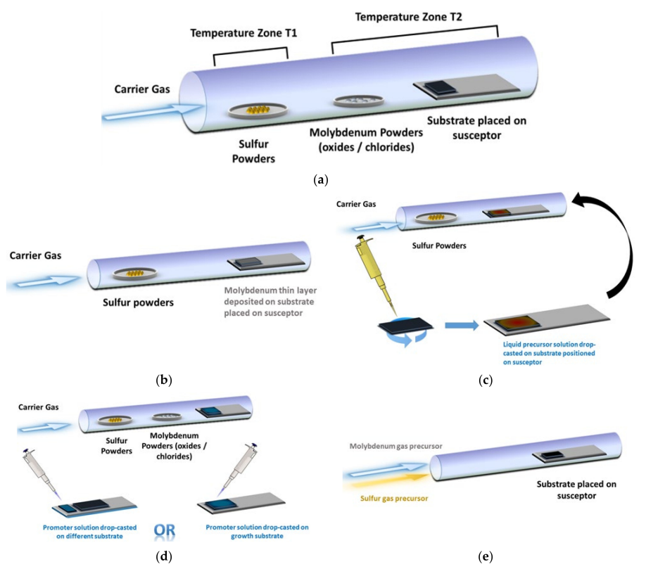

Figure 2.16 Schematic representation of the CVD tube in different configurations for MoS2 thin film growth: (**a**) with solid precursors separated from each other; (**b**) with solid Mo precursor deposited on the substrate in advance; (**c**) with liquid Mo precursor deposited on the substrate; (**d**) with solid precursors and drop-casted promoters (either on the growth substrate or on a different substrate); (**e**) with gaseous precursors (Luca Seravalli, 2021).

In the standard horizontal setup, a quartz tube with dimensions of approximately 1 m in length and a diameter of 2-5 cm is employed. Heating is achieved through a resistor element wrapped around the tube. The MoS2 deposition process requires the temperature in the range of 600-800 ℃. In certain instances, an additional heating zone in the range of 100-200 ℃ is required for the S precursor. For improved reproducibility and control, it is more convenient to independently heat this supplementary zone, where the S precursor is initially located. Alternatively, it is feasible to directly deposit the Mo precursor onto the substrate, either in solid form or as a liquid solution. Growth promoters may be added on the growth substrate or on a separate substrate to enhance the processibility. Lastly, the use of gaseous precursors eliminates the need to place the precursors inside the tube before initiating the process (Luca Seravalli, 2021).

### Overview on the performance of 1L-MoS2 direct X-ray detectors

The mechanical exfoliation and CVD methods are only a few examples of the fabrication techniques for MoS2 thin films. Such sophisticated, yet crucial, production process deserves much more comprehensive discussion, however, the analysis would draw exceedingly large attention from the main objective of this section. The main idea still sticks to the perspective of using the MoS2 thin films for X-ray detection. Since, as already mentioned, there has not been much research on usage of MoS2 specifically for X-ray sensing, only a few of reports could provide any data about the sensitivity of MoS2-based detectors. Regarding concretely my research, the part concerning the characterization of 1L-MoS2 X-ray detectors was motivated by their excellent performance previously reported in the work of Taffelli *et al* (Alberto Taffelli, 2023). My objective was to thoroughly examine phototransistors based on 1L-MoS­2 thin films to verify if they exhibit sensitivity higher than that of the organic X-ray detectors, in particular, of the TMTES:PS based sensors.

Therefore, since the results from my work concerning the 1L-MoS2 X-ray detectors will be inseparably related to the data from Taffelli *et al.*, it is important to introduce beforehand their research and its outcome.

The goal of the research group was to showcase the effective usage of thin-film MoS2 as a potential semiconducting material for direct X-ray detection. For this purpose, the group constructed a planar detector based on the photoconductor architecture, utilizing a monolayer MoS2 (1L-MoS2) as an active layer. The device was exposed to X-rays within the energy range of 10-100 keV. Furthermore, to enhance the detector photoresponse to X-rays, a scintillator film was employed to induce light-matter interaction in the visible light spectrum. This strategy led to a threshold increase in photocurrent by converting a fraction of the radiation into the visible spectrum.

The 1L-MoS2 thin films were fabricated with the exfoliation of a MoS2 bulk crystal through a thermally activated metal-mediated process. With this process, 1L-MoS2 was acquired on a thin Au film. After that a monolayer MoS2 film was then covered with a polystyrene film of ~1 µm via spin coating. The gold film was then etched leaving the MoS2 monolayer embedded in PS, which was then transported to the substrate through wet transfer. The resulting X-ray detector was constructed on a soda-lime glass substrate, where gold (Au) electrodes with the thickness of 100 nm were deposited via thermal evaporation. The active channel was created by the MoS2 and was supposed to have the area of 1×0.3 mm2 determined by the area between the collecting electrodes. The thickness of the active channel was evaluated as 0.9 nm. The scintillator film with the thickness of 0.2 nm, was based on polydimethylsiloxane (PDMS) containing gadolinium oxysulphide doped with terbium (Gd2O2S:Tb) and was deposited on top of the PS film, thus, resulting in the layered structure depicted in Fig. 2.12 (Alberto Taffelli, 2023).

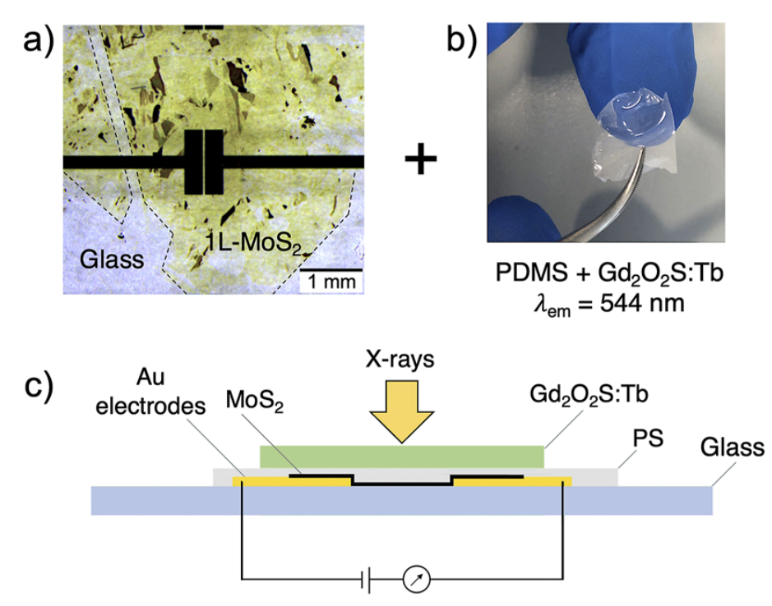

Figure 2.17 (**a**) An optical image taken with a microscope of the top view of the X-ray detector device based on 1L-MoS2. The dashed line outlines the MoS­2 flake, under which the Au electrodes are deposited; (**b**) An image of the scintillator film based on PDMS and loaded with Gd2O2S:Tb; (**c**) A schematic cross-section of the 1L-MoS2-based X-ray detector (Alberto Taffelli, 2023).

The fabricated MoS2 detector then underwent X-ray testing to test its sensitivity under direct radiation. The active channel was constantly biased under *Vbias* = 5 V. The X-rays were generated by a tungsten anode (*WKα* = 59 keV) operated at peak voltages of 40, 100, 150, 195 kV filtered with 3 mm of copper. The radiation was generated in the form of periodic pulses of 20 s in the *on*-regime and 40 s in the *off*-regime. The X-ray response of the MoS2 detector was measured both with and without the scintillator film placed on top of the detector. The PS layer on top of MoS2 was estimated to absorb less than 0.01 % of the incident radiation, therefore, it was not supposed to deteriorate the obtained data from the active channel (Alberto Taffelli, 2023).

Consequently, the photoresponse exhibited an increase of up to three times when incorporating the scintillator film onto the detector. The amplification was ascribed to the generation of additional visible photon from the scintillator through indirect X-ray photoconversion. Furthermore, the MoS­2 detector consistently demonstrated a photoresponse to incoming X-rays over subsequent irradiation cycles, which indicated the reproducibility of the measurements (Alberto Taffelli, 2023).

As a result, the sensitivity per unit volume was evaluated to be within the range of 108-109 µC/(Gy·cm3) with the maximum value of 2.3 × 109 µC/(Gy·cm3). The sensitivity per unit area was estimated to be in the order of 10-100 µC/(Gy·cm3) (Alberto Taffelli, 2023).

According to these numbers, we can conclude that TMDCs, in particular, monolayer MoS2, can be competitive (in relation to fully-organic based) semiconductors for thin-film flexible sensing electronics. Even though TMDCs have not yet been so rigorously studied as organic-based X-ray detectors, it is evident that MoS2-based X-ray detectors are among realizable alternatives to conventional inorganic sensing devices. For this purpose, the first part of my research was the characterization of thin film MoS­2-based X-ray detectors in the form of a phototransistor. The final goal of this study was the estimation of their sensitivity and overall performance.

In the next chapter I shall describe the full process of the experimental part, including also the methods of fabrication of the devices. and the instruments used during the research.

# Experimental Methods

The experimental part is typically composed of two parts. The first part considered the characterization of MoS2-based phototransistors, whereas the second dealt with TMTES:PS-based phototransistors. For each semiconductor materials, the correspondent study included initial full IV-characterization of the devices and subsequent characterization of the detectors under X-ray radiation. Each device of both the MoS2- and TMTES:PS-based X-ray detectors have the top-contact and bottom-gate phototransistor architecture. The gate port was performed by a Si wafer.

In this chapter I will first discuss the architecture of the MoS2-based detectors and their fabrication methodology. After that I will describe the IV-characterization procedure and which electrical parameters were calculated. Finally, the characterization of the devices under X-ray radiation will be discussed in detail. Analogously, in the second part of this chapter I will describe the similar procedure of IV-characterization and examination under X-rays for the TMTES:PS devices.

## Instrumentation used both for MoS2 and TMTES:PS samples

In this section I will describe the tools that were used for IV characterization and X-ray measurements for both detector batches. The actions described in this section, were made to both MoS2 and TMTES:PS samples.

* **Faraday cage**

The IV-characterization was performed by using a Faraday cage (Fig. 3.1). Initially, while performing the IV characterization of MoS2 samples, in some devices *IGS* demonstrated short circuit through the gate. Such anomaly could be related to the connection between the bottom Si substrate serving as the gate port, and the metallic surface of the Faraday cage, on which the samples were placed. Therefore, in order to avoid short circuit in subsequent measurements, a parafilm sheet was first put onto the surface of the cage and then the samples were placed on the film. After that, short circuit was not output.

In order to reach the gate provided by the Si substrate, a small area of the layers was scratched from the substrate. All the operations were controlled through an optical microscope. Once a sample was settled, copper (Cu) electrodes were connected to the drain and source pads and to the scratched surface indicating the gate port. In order to apply a voltage between the pads and to measure the current between them, a 2-channel source measure unit (SMU) Keysight B2912A was used, where Ch1 was referred to gate (G) and Ch2 was referred to drain (D). The source (S) pad was referred to ground and was connected to both channels through a “Low Force” port. The G and S connection was realized with triaxial cables, whereas S was connected to the SMU with two coaxial cables.

|  |  |
| --- | --- |
| **(a)** | **(b)** |

Figure 3.1 Experimental setup for IV characterization of the MoS2 and TMTES:PS samples: (**a**) Faraday cage; (**b**) the SMU instrument to measure the current-voltage behaviour of a transistor.

It is noteworthy to mention again that such configuration was applied to both batches of MoS2 and TMTES:PS samples. The SMU was operated by a computer through a special software, developed specifically for such measurements. For each sample, the “Initial Delay”, “Delay per Step” and “Aperture time” were set as 100 ms, 100 ms and 20 ms, respectively. During the IV characterization, for each transistor transfer characteristics (*IDS*(*VGS*) and *IGS*(*VGS*)) in linear and saturation regimes and output characteristics (*IDS*(*VDS*) and *IGS*(*VDS*)) were measured.

* **X-ray measurements**

For the characterization of the samples under X-rays, I used a compact X-ray tube with a tungsten (W) target anode. The Hamamatsu power source operates the X-ray tube with the voltage between the electrodes in the range $V_{X-ray}∈\left[40, 150\right]$ kV and with the current of incident electrons in the range $I_{X-ray}∈\left[10, 500\right]$ µA. As a result, the maximum energy of the outcoming photons is in the range between 40 keV and 150 keV. The exit for the X-rays is covered with a beryllium (Be) window. To control the dynamics of the incoming radiation, the X-ray beam is switched on/off with a mechanical lead shutter placed in front of the Be window. Both the X-ray tube and the shutter are operated via a special software “MFX Control Software”, where different parameters (*VX-ray, IX-ray,* shutter on/off frequency) are set up. Additional parameter “Acquisition time” (time for measurement of one point) was set as 500 ms during the measurements.

Before each experiment, it is necessary to perform the warmup procedure of the X-ray tube during 15-30 minutes. Both the X-ray source and the sample holder are located within a chamber covered with lead and supplied with an interlock prevention mechanism.

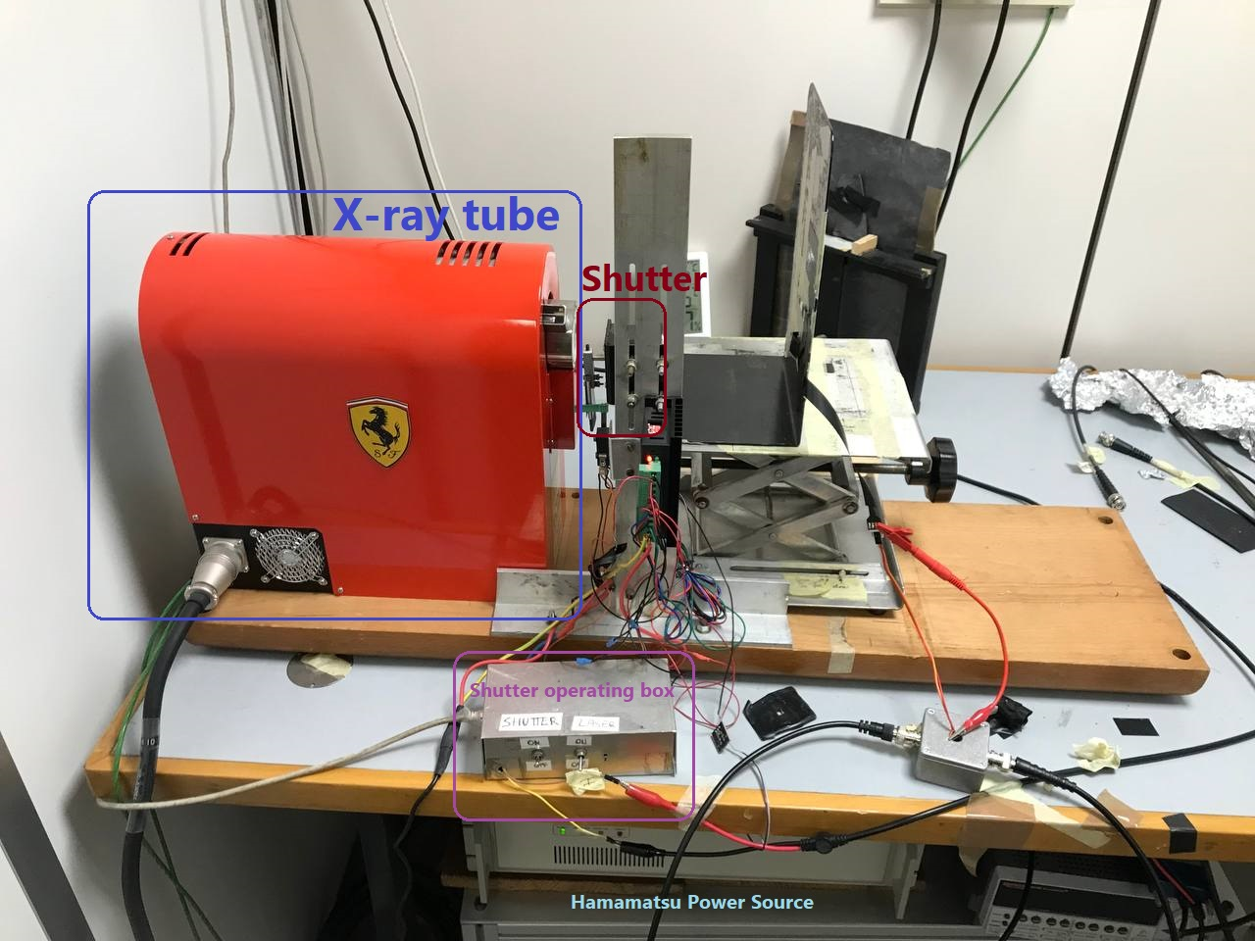

Figure 3.2 Experimental setup for the characterization of a phototransistor under X-ray radiation.

During X-ray exposure, MoS2 and TMTES:PS phototransistors were placed in different placeholders with micromanipulators. Their detailed description will be provided in the sections regarding the X-ray measurement procedure. To control the current (*IDS* and *IGS*) and voltage (*VDS*and *VGS*) in a device between the electrodes, another 2-channel SMU Keithley 2614B was used, where similar configuration was presented: chA was connected to G, chB was connected to D, while S was referred to the ground through connection to both channels.

|  |  |  |
| --- | --- | --- |
| **(a)** | |  |
| **(b)** | **(c)** | |

Figure 3.3 Fragments of the experimental setup for X-ray measurements: (**a**) Hamamatsu power source unit for the X-ray tube; (**b**) Lead shutter in front of the Be window of the X-ray tube; Keithley SMU providing control for IV characterization of a phototransistor under X-ray radiation.

* **Glovebox**

Both the MoS2 and TMTES:PS phototransistors were not encapsulated, therefore, the active channel of a device was prone to become contaminated with air. In order to avoid intense degradation of the semiconductors, after each experimental session, the MoS2 samples were placed in a glovebox filled with nitrogen and almost-zero concentration of oxygen. On the other hand, when the TMTES:PS phototransistors arrived, the glovebox was out of use for 1-2 months. Therefore, between experimental sessions, the TMTES:PS detectors were covered with aluminum foil and kept in a plastic box under ambient conditions.

## MoS2 Samples

The batch of the MoS2-based phototransistors (Fig. 3.5(a)) contains 11 Si substrates (denoted as *samples*) with one or more transistors (*devices*) fabricated on each substrate (Fig. 3.5(b, c)). Each device has the top-contact and bottom-gate architecture and is deposited on a substrate made of a Si wafer, which also serves as a gate port and which has a silicon oxide SiOx layer on top serving as an insulating layer in a phototransistor. On top of the SiOx layer a benzocyclobutene (BCB) film of 50 nm thick is deposited (WHY IS THIS FILM USED?). On such multilayer structure several MoS2 flakes are placed (mechanical exfoliation?). Finally, collecting drain and source electrodes made of gold (Au) and chromium (Cr) with thicknesses of 45 nm and 3 nm respectively, are outstretched to the MoS2 flakes, which in this configuration form an active channel. WHY IS CHROMIUM USED? Each device has an active channel with the length *L* and width *W*, which are determined by the geometry of collecting electrodes, and with the thickness, which is defined by the thickness of a certain MoS2 flake. It is noteworthy to stress out that some MoS2 flakes can have dimensions different from the area between the electrodes, for example, a semiconducting nanosheet can be thicker or thinner than the defined width *W* Fig. 3.5(d), or have a non-regular shape. Such imperfections must be taken into account during calculating electrical parameters of a device, since they might distort the obtained parameter from its real value.

Each device from the MoS­2 batch had been previously undergone an IV characterization at the fabrication laboratory (UNIVERSITY OF STRASBOURG). As a result, the operation voltage was determined to vary in the range of:

* $V_{GS}∈\left[-60, 60\right]$ V
* $V_{DS}∈\left[0, 1\right]$ V

Therefore, all the subsequent measurements (IV characterization and X-ray measurements) were undertaken within this voltage range.

|  |  |  |
| --- | --- | --- |
| **(a)** | |  |
| **(b) (c)** | **(d)** | |

Figure 3.4 (**a**) Schematic cross-section of a MoS2-based phototransistor; (**b**) map of a single substrate (sample) with a group of the devices; (**c**) optical images of MoS2 active channels in each device; (**d**) active channel of a phototransistor denoted as Sample12_device1. The orange and yellow lines indicated the edges of the MoS2 flake and pf the Au Pads, respectively.

### Fabrication methods

More information on preparation is required.

### IV characterization of the MoS2 phototransistors

The IV-characterization was accomplished by using the mentioned Faraday cage (see above). First, the transfer characteristics in saturation regime (denoted as trf_Sat for brevity) were undertaken while keeping *VDS* at maximum value of 1 V by sweeping the gate voltage *VGS* from -60 V to 60 V with the step of 0.5 V. Once the trf_Sat characteristics demonstrated that the device worked properly, the output characteristics was performed by varying *VDS* from 0 V to 1 V with the step of 0.1 V, while *VGS* varied from -30 V to 60 V with the step of 10 V, so that 10 curves were obtained. In its turn, the output characteristics allowed me to identify the *VDS* range for linear and saturation regimes of the device. Finally, by picking a *VDS* value in the linear regime (typically it was ~0.1 V), the transfer characteristics in linear regime (to be short, denoted as trf_Lin) was fulfilled. To summarize, the whole IV characterization could be described in the following steps

1. **trf_Sat**: $V_{DS}=1$ V, $V_{GS}∈\left[-60, 60\right]$ V, step = 0.5 V;
2. **Output**: $V_{DS}∈\left[0, 1\right]$ V, step = 0.1 V, $V_{GS}∈\left[-30, 60\right]$ V, step = 10 V;
3. **trf_Lin**: $V_{DS} \sim 0.1$ V, $V_{GS}∈\left[-60, 60\right]$ V, step = 0.5 V.

During the IV characterization of the MoS2 devices, several frequent anomalies have appeared. First, almost all devices performed hysteresis in during transfer characteristics in saturation regime, among which a half (17 devices out of 34) had significant hysteresis. Besides, almost a third of devices (12 out of 34) performed output characteristics, in which the *IDS*(*VDS*) behaviour was almost ohmic and showing no field effect. Lastly, several devices (9 out of 34) output no signal, which could be explained by bad connection between the Au pads and the copper electrodes of the Faraday cage or between the pads and a MoS2 flake. During the transfer characteristics (both in linear and saturation regimes), the devices demonstrated the current between gate and source, that is, the leakage current through the insulating layer in the range of |*IGS*| ~10-9 A, which does not imply on significant leakage through the SiOx insulator.

|  |  |
| --- | --- |
| **(a)** | **(b)** |
| **(c)** | **(d)** |

Figure 3.5 IV characterization of a MoS2-based phototransistor denoted as Sample11_device3: (**a**) transfer characteristics in saturation regime at *VDS* = 1V, the black curve represents |*IDS*|, the red curve depicts |*IGS*| ~ 10-9 A, small hysteresis is present. (**b**) The plot $\sqrt{\left|I_{DS}\right|}\left(V_{GS}\right)$ in saturation regime; the red line indicates linear fit used for calculating threshold voltage *Vth* and mobility *µ*. (**c**) transfer characteristics in linear regime *VDS* = 0.1V. (**d**) output characteristics; the field effect is present at *VGS* < 30V. Above *VGS* = 30V the device starts to perform ohmic behaviour with linear dependence of *IDS* on *VDS*.

In the next Chapter I will discuss the results of the IV characterization and provide possible explanation for the anomalous phenomena of the devices. Now I shall discuss the characterization procedure of the devices under X-ray radiation.

### Characterization of the MoS2 phototransistors under X-rays

After the initial IV characterization, the MoS­2-based devices were exposed to the X-ray radiation from the X-ray tube. The devices were placed at the distance of 30 cm from the Be window of the X-ray tube (measured with a meter). The general strategy for each device was the following:

1. First, to undertake the transfer characteristics in saturation regime in the dark (without incident radiation) to verify that the phototransistor works properly.
2. If the device operates correctly, the X-ray radiation was turned on. The goal of the X-ray measurements is to calculate the sensitivity of the MoS2 active channel. For this purpose, a photocurrent due to impinging photons should be measured at different dose rate values. In order to generate X-ray radiation with varying dose rate, the X-ray tube voltage is kept at *VX-ray =* 150 kV, while the X-ray tube current *IX-ray* is sequentially equal to 500 µA, 400 µA, 300 µA, 200 µA and 100 µA. During each radiation exposure, the shutter performs the on/off switching cycle, such that the radiation impinges on the device for 10 seconds (*on*-mode) and then is shut for 10 seconds (*off*-mode) by the shutter. As a result, at least four radiation pulses (depicted as photocurrent peaks of *IDS* and *IGS*) of 10 seconds each should be registered. After the last X-ray pulse, the device is kept in the dark for at least 60 seconds.

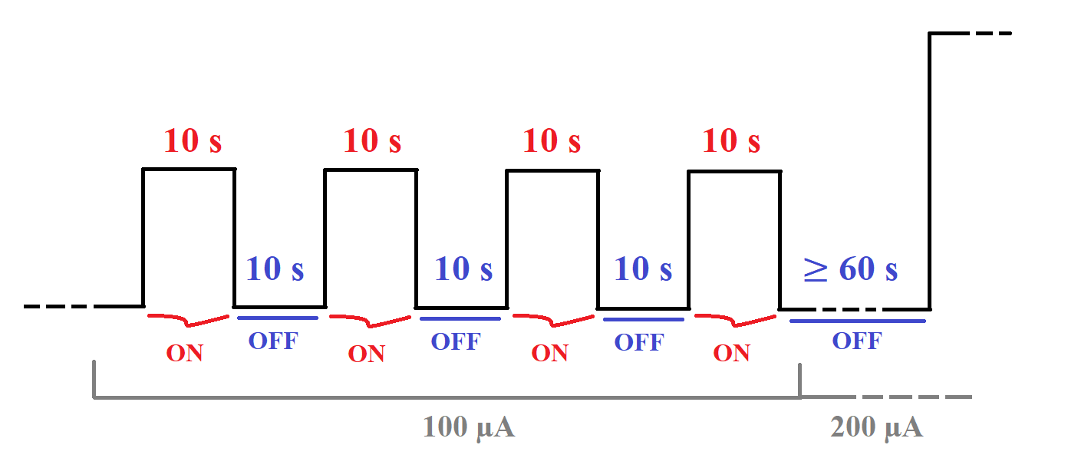

Figure 3.6 Schematic representation of an irradiation exposure at *IX-ray* = 100 µA. By using the shutter, the X-ray radiation is performed in the form of pulses of 10 seconds long. Normally four pulses are collected. After each irradiation sweep the device is kept in the dark for 60 seconds or more.

1. While performing the X-ray pulses, the MoS­2 devices work in saturation regime with maximum voltage between source and drain *VGS* = 1 V. The gate voltage *VGS* is varied in the range from -50 V to 50 V.In order to obtain the highest photocurrent from *IDS*, the photoconductive gain must be taken into consideration. As was mentioned in section 2.3.1 in Chapter 2, in phototransistors the increasing the gate polarization *VGS* leads to the enhancement of the photoconductive gain *G*, which in its turn increases the photocurrent signal. At the same time, increasing *VGS* also leads to the rise of drift dark current, which shall hide the relatively small photocurrent ( $\left|∆I_{Ph}\right|∝{10}^{-9}$ A) due to the larger order of |*IDS*| magnitude. As a result, some kind of “trade-off” between the photoconductive gain and the magnitude of |*IDS|* must be accomplished. To do this, we made a condition to keep *IDS* in the order of ~10-6 A **for each MoS2 device** by operating *VGS* is a corresponding range.

Once indicating the following rules, we started the X-ray exposure procedure. First, a MoS2 device (denoted as *Sample9_device3*) was placed with in a special box (Fig. 3.7(a)) with a cover made of lead (Pb) (to prevent excess X-ray radiation beyond the detector area). The device was fixed in the box with a small piece of a scotch tape. After that three manipulators in the form of copper wires were connected to the Au pads (drain and source) and to the gate port (Si surface uncovered by scratching) with the use of silver paste RS 180-3600 (Fig. 3.7(b)).

|  |  |
| --- | --- |
| **(a)** | **(b)** |

Figure 3.7 Experimental setup for the characterization of the MoS­2 phototransistors: (**a**) a box for the X-ray detectors covered with a lead plate; the red circle indicates the window through which incoming X-ray radiation impinges on the detector. (**b**) silver paste RS 186-3600 to provide rigid connection between the micromanipulators and the device electrodes.

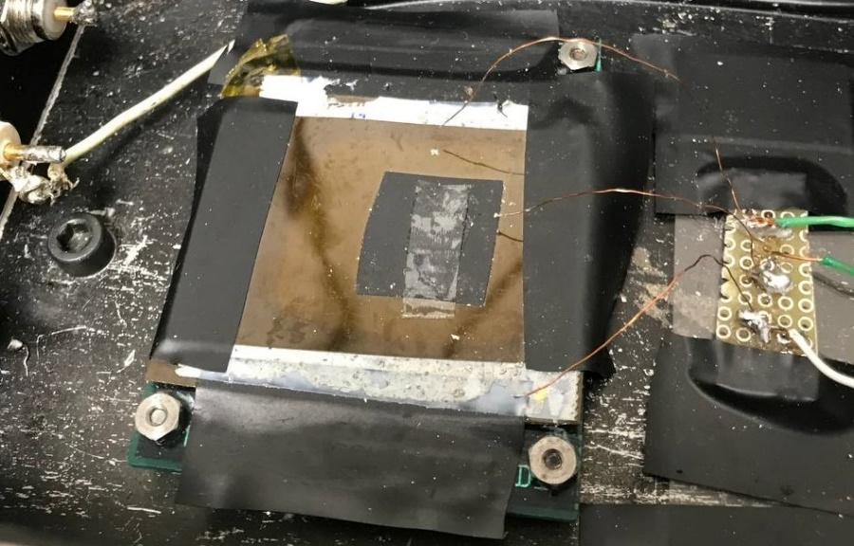

Figure 3.8 Depiction of the lead box. The placeholder for a phototransistor is equipped with a piece of a two-side scotch tape. Three micromanipulators for source, drain and gate reference are represented by three copper wires, which are connected to the pads with a small amount of silver paste.

Once the *Sample9_device3* phototransistor was fixed in the placeholder, the lead box was located in front of the X-ray tube at the distance of 30 cm. To protect the device from artificial light, the lead box was also covered with aluminum (Al) foil. According to the general strategy, initial transfer characteristics in saturation regime were undertaken. As a result, the device performed a short circuit through the insulating layer. Similarly, another device (denoted as *Sample10_device6*) showed short circuit through the insulator after using the silver paste.

A possible explanation for such phenomenon could be the intercalation of the silver paste through the Au pads and the SiOx insulator layer reaching the Si gate electrode, thus, creating a short circuit between the source and gate electrodes. In order to avoid the intercalation issue, we decided to stop using the silver paste and replaced the lead box with a Nextron micromanipulator box.

|  |  |
| --- | --- |
| **(a)** | **(b)** |

Figure 3.9 (**a**) Nextron box for the X-ray measurements of the MoS­2-based detectors; the device is equipped with six micromanipulators to connect the pads of the detector. (**b**) A close view to the MoS2 detector fixed in the Nextron box; in order to avoid connection of the Si substrate with metallic surface, the device is deposited on a parafilm sheet.

In order to prevent the MoS­2 detector degradation upon artificial light, the Nextron box was also covered with Al foil during the whole characterization procedure. Before each irradiation cycle, each device performed transfer characteristics in saturation regime. The common features for each MoS2 device are the following:

* Long (up to 10 minutes) relaxation of the drain-source current *IDS*, which could be caused by high concentration of traps in the MoS2 active channel;
* Even though the initial drain-source current was *IDS* ~ 10-6 A, it did not sustain at this order of magnitude and sometimes relaxed down to *IDS* ~ 10-9 A;
* Several samples (four out of 18) demonstrated satisfactory transfer characteristics, however, there was no signal to incoming radiation even at *IX-ray* = 500 µA;
* Some samples performed anomalous behaviour: when the X-ray radiation was switched *on*, the current *IDS­* through the active channel decreased more rapidly than in the dark. On the other hand, when the radiation was switched *off*, the current *IDS* decreased more slowly.

The results of the MoS­2-based detectors and analysis of their performance under X-rays will be provided in the next chapter. For consistency, in the subsequent sections I would like to discuss the experimental procedure relation to the TMTES:PS-based X-ray detectors.

## TMTES:PS samples

After the characterization of the MoS2-based X-ray detectors, the second part of the experimental research was to study the X-ray detectors based on the TMTES:PS organic semiconductor. It is noteworthy to mention that this research is basically a continuation of a more far-reaching study regarding TMTES:PS based X-ray detectors initiated by (Adriàn Tamayo, 2022), which indicates that the fabrication methods of the devices are identical to the procedure discussed in the paper.

### Fabrication methods

The fabrication process of the TMTES:PS based X-ray detectors was carried out at the *Institute de Ciencia de Materials de Barcelona* (ICMAB) within the research group of Dr. Marta Mas-Torrent. Before the deposition of the organic semiconductor blend, the drain and source electrodes were fabricated via thermal evaporation of 5 nm of chromium (Cr) (acting as adhesion layer) followed by 40 nm of gold (Au) onto a heavily *n*-doped silicon (Si) wafer (provided by Si-Mat) with a 200 nm thick layer of SiO2. After the film deposition, interdigitated Au/Cr electrodes were patterned by photolithography process. The resulting devices were designed in the form of a pixel with the active area *A* = 4.25 × 10-3 cm2 made with the channel length *L* = 25 µm and the channel width *W* = 2500 µm, thus, keeping the width/length ratio equal to 100. The substrates were then cleaned by sonication with acetone and isopropanol in HPLC grade and then dried under nitrogen flow.

The surface of the source and drain Au/Cr electrodes was then chemically modified with a self-assembled monolayer (SAM) of 2,3,4,5,6-pentafluorothiophenol (PFBT, obtained from Sigma-Aldrich). The Au surfaces were exposed to a UV ozone cleaner for 25 minutes and then immersed in a 15 × 10-3 M solution of PFBT in isopropanol for 15 minutes. Finally, the prepared substrates were cleaned with pure isopropanol to remove the excess PFBT and dried with a nitrogen flow.

Once the substrates for the active channel deposition was completed, the organic semiconductor preparation took place. 1,4,8,11-Tetramethyl-6,13-triethylsilylethynyl pentacene (TMTES) and polystyrene (PS) of 280 000 g/mol (or 280 kDa) were bought from Ossila (TMTES-pentacene, n.d.) and Sigma-Aldrich (Polystyrene (PS), n.d.), respectively, and employed with further treatments. The TMTES and PS solutions were prepared in anhydrous chlorobenzene with a final concentration of 2.0 % w/w. For blended solutions, the TMTES and PS solutions were mixed in a TMTES:PS ratio of 17:3, 9:1, 19:1 and 39:1. Before the deposition, the blends were heated to the temperature of used for the coating process. The TMTES:PS semiconducting layer was deposited on the prepared substrates via the Bar-Assisted Meniscus Shearing (BAMS) technique. The BAMS deposition procedure was conducted at 105 ℃ and with a coating speed of 10 mm per second. It is important to point out that the whole device fabrication process was performed under ambient conditions with no post-thermal treatments of the samples.

After the fabrication process, the prepared devices were placed in a plastic box filled with nitrogen and transferred to the Department of Physics at the University of Bologna. The whole batch consists of four sets of the phototransistors classified by the TMTES:PS ratio, which has values of 17:3, 9:1. 19:1 and 39:1. The molecular weight of PS in all devices is the same and equals to 280 kDa. Each set with a specific TMTES:PS ration includes two Si substrates (*samples*), each of which accommodates four phototransistors (*devices*) with common gate represented by the heavily *n*-doped Si wafer. In total, the whole batch is composed of 32 devices, 8 for each TMTES:PS ratio deposited on two substrates.

|  |  |  |
| --- | --- | --- |
| **(a)** | |  |
| **(b)** | **(c)** | |

Figure 3.10 (**a**) Schematic cross-section of a TMTES:PS based phototransistor. (**b**) A single substrate (*sample*) configuration. Four phototransistors (*devices*) are arranged in a matrix and are denoted by the numbers 00, 01, 10, and 11. The common gate area (grey circle) indicates a surface of the Si wafer, which is used as the gate electrode. (**c**) Optical microscope image (left) and cross-polarized optical microscope image (right) of the TMTES:PS thin film deposited by BAMS on a Si/SiO2 substrate with the interdigitated Au electrodes (Adriàn Tamayo, 2022).

### IV characterization

Similarly to the first part of the research related to the MoS­2 detectors, the TMTES:PS devices initially underwent IV characterization. The data collection was performed in collaboration with my colleague Giulia Napoletano. To perform the IV characterization, we used the same Faraday cage and the SMU, which had also been exploited for the MoS2 phototransistors.

The IV characterization of TMTES:PS devices included the output characteristics of a device and the transfer characteristics in both saturation and linear regimes, where the voltage sweep was performed forward and backward. Initially, the devices with the highest quantity of PS indicated by the TMTES:PS ratio of 17:3 were characterized, then subsequently reducing the proportion by considering the ratios of 9:1, 19:1 and finally of 39:1. First, we achieved the output characteristics in order to determine the regions for the linear and saturation regimes. Since the TMTES:PS organic semiconductor is a *p*-type semiconductor, the drain-source voltage *VDS*was operated at values below zero. For the devices with the TMTES:PS ratio of 17:3 and 9:1, *VDS* ranged starting from 0 V to -10 V with the step of 0.5 V. The gate voltage *V­GS* was swept from 5 V to -5 V with the step of 2.5 V, that is, the output characteristics depicted five curves. The linear regime was determined at *VGS* ~ -0.5 V. The next step was to obtain the transfer characteristics in saturation and subsequently in linear regimes (*trf_Sat* and *trf_Lin* for brevity). For this purpose, the gate voltage *VGS* ranged from 5 V to -5 V with the step of 0.1 V, whereas *VDS* was fixed at -10 V for the saturation regime and at -0.5 V for the linear regime.

When we moved to the devices with the TMTES:PS ratio of 19:1 and 39:1, it was decided to extend the bias range both for *V­GS* and *VDS* for more comprehensive characteristics. For this purpose, the output characteristics were performed at *VDS* ranging from 0 V to -20 V with the step of 0.5 V, whereas *VGS* changed from 10 V to -15 V with the step of 5 V. The transfer characteristics in saturation and linear regimes were obtained by fixing *VDS* at -10 V and -0.5 V, respectively, and sweeping *VGS* from 20 V to -15 V with the step of 0.1 V. As a whole, the IV characterization procedure can be schemed as follows:

1. **Output**: $V_{DS}∈{\left[0, -10\right]}_{st=0.5 }$ V, $V_{GS}∈{\left[5, -5\right]}_{st=2.5}$ V – for TMTES:PS = 17:3 and 9:1

$V_{DS}∈{\left[0, -20\right]}_{st=0.5 }$ V, $V_{GS}∈{\left[10, -15\right]}_{st=5}$ V – for TMTES:PS = 19:1 and 39:1

1. **trf_Sat**: $V_{DS}=-10$ V, $V_{GS}∈{\left[5, -5\right]}_{st=0.1}$ V – for TMTES:PS = 17:3 and 9:1

$V_{DS}=-10$ V, $V_{GS}∈{\left[20, -15\right]}_{st=0.1}$ V – for TMTES:PS = 19:1 and 39:1

1. **trf_Lin**: $V_{DS}=-0.5$ V, $V_{GS}∈{\left[5, -5\right]}_{st=0.1}$ V – for TMTES:PS = 17:3 and 9:1

${ V}_{DS}=-0.5$ V, $V_{GS}∈{\left[20, -15\right]}_{st=0.1}$ V – for TMTES:PS = 19:1 and 39:1

A typical result of the IV characterization for a TMTES:PS based device is depicted below. As a result, the TMTES:PS phototransistors exhibited good output characteristics, where the field effect was expressed in every device. The transfer characteristics also performed well, however, several devices experienced an anomalous phenomenon denoted as the “double hump” effect, where the transfer from the OFF mode to the ON mode initially proceeded with a smaller slope, but then it abruptly increased. This effect prevailed for the devices with the TMTES:PS ratio of 17:3 and 9:1. Additionally, almost all devices exhibited no hysteresis. The average gate-source leakage current |*IGS*| had its maximum value in the order of ~10-8 – 10-7 A, which can imply on moderate leakage through the insulating layer.

|  |  |
| --- | --- |
| **(a)** | **(b)** |
| **(c)** | **(d)** |

Figure 3.11 IV characterization of a TMTES:PS based phototransistor denoted as *Sample18_device01* with the TMTES:PS ratio of 19:1. (**a**) transfer characteristics in saturation regime at *VDS* = -10 V, where the black curve depicts |*IDS*| and the red curve represents |*IGS*| ~ 10-9 A. (**b**) The plot in saturation regime; the red line indicates linear fit used for calculating threshold voltage *Vth* and mobility *µ*. (**c**) Transfer characteristics in linear regime at *VDS* = -0.5 V. (**d**) Output characteristics; the field effect is seen at each *VGS* with linear regime expanding with increasing *VGS*.

### Characterization under X-rays

Once the IV characterization was completed, the TMTES:PS devices were exposed to X-rays. The X-ray tube and the SMU were the same that had been employed for the MoS­­2 detectors. As previously mentioned, my goal was to continue the research on TMTES:PS based phototransistors, which had been conducted by my colleague Alessandro Galeazzi. For this purpose, I created the same experimental conditions that were present during Alessandro’s work. To place a TMTES:PS sample in a vertical position, the lead box (Fig. 3.7(a)) was used. As with the MoS2, a sample was fixed with a piece of a scotch tape, whereas the silver paste (Fig. 3.7(b)) was used to connect the micromanipulators with the Au pads and the Si gate port. In order to avoid the excitation of the active channel under artificial light, the connection procedure was performed in the room illuminated with yellow light.

After a TMTES:PS based phototransistor was properly placed in the lead box, it was mounted in front of the X-ray tube at the distance of 17 cm between the sample and the chassis of the X-ray tube (the front edge of the red body of the X-ray tube). The X-ray measurement strategy was basically the same as for the MoS2 samples and included the following steps:

1. Initially, the transfer characteristics in saturation regime are collected in the dark to test the performance of a phototransistor.
2. Once it is verified that the device functions properly, the X-ray radiation with different dose rate is induced. The biasing voltage in the X-ray tube is fixed at *VX-ray* = 40 kV. The current between the cathode and the anode is subsequently equal to *IX-ray* = 500 µA, 350 µA, 200 µA and 100 µA. The incident radiation is emitted in the form of periodic pulses of 60 seconds in *on*-mode and 60 seconds in *off-*mode. At least four photocurrent peaks should be registered. To obtain stable dark current of a phototransistor and also to perform consistency for different measurements, the radiation pulses are induced after 120 seconds from the beginning of a measurement. The first photocurrent peak should not be considered as a reliable signal, since during the first X-ray pulse, the photogenerated charge carriers start to fill traps in the active channel, which reduces the collected signal.
3. During the X-ray measurements, the phototransistor is biased at gate voltage *VGS* = -2.5 V and at drain-source voltage *VDS* = -10 V.

From the device characterization under X-rays, some tendency could be extracted:

* Almost all the devices show (to certain extent for each device) the anomalous effect of decreasing photocurrent after some time (~10-30 seconds) at impinging radiation. Such phenomenon was denoted as “*decreasing peaks*”. The most relatively weakly manifested “decreasing peaks” occurred for the 17:3 ratio, while it intensified for 9:1 ratio and for the last two proportions turned into “negative peaks” phenomenon, which is described below.
* For the 19:1 and 39:1 ratio values, all the devices exposed anomalous behaviour similar to the MoS2 detectors: in the *on-*mode of the X-ray radiation, the absolute value of the current |*IDS*|*­* through the active channel started to decrease more rapidly than in the dark. On the other hand, when the radiation was switched *off*, the current *IDS* decreased more slowly. As a result, such TMTES:PS based detectors output “*negative peaks*” in response to X-ray photons.

Once the experimental part of the research was fully accomplished, I embarked on thorough analysis of the obtained data. In Chapters 4 and 5 I will discuss how the main electrical parameters for the MoS­2 and TMTES:PS phototransistors were evaluated.

# Results for MoS2­-based X-ray detectors

As was previously mentioned in Chapter 3 (3.2.2), the IV characterization of the MoS2-based X-ray detectors was not as successful as expected, since many side effects came up. With 34 phototransistors in total, 10 devices exposed no drain-source current at external *VGS* and *VDS* biasing, among which one transistor did not work properly because of constantly unstable connection between the tips of the Faraday cage and the Au pads. Other 9 devices had *IDS* ~ 10-9 A, which implied that either drain or source (or both) electrodes were disconnected from the active channel. According to the transfer characteristics undertaken by Professor Tamayo research group right after the fabrication, only 1 out of 9 non-working devices had been already verified to be broken, while other 8 detectors had performed satisfactory transfer characteristics. Consequently, possible explanation to such device fragility could be highly unstable connection between the MoS2 flakes with the electrodes, which was completely damaged during transportation of the devices or handling them during the characterization.

Another significant side effect of the MoS2-based devices was a hysteresis loop in transfer characteristics collected both in saturation and linear regimes and inherent in each device with no exception. For some devices the hysteresis was nearly insignificant, however, a half of the whole batch, that is, 17 out of 34 detectors exhibited hysteresis of a noticeably large area, which was impossible to omit (Fig. 4.1). It is noteworthy to mention that the hysteresis loop was present mainly in the transfer characteristics, while the output characteristics exhibited almost zero difference in *IDS* versus *VDS* behaviour at constant *VGS* between forward (from -60 V to +60 V) and backward (from +60V to -60 V) sweeps of *VDS*. The explanation to such phenomenon could possibly be a high density of traps in the MoS2 semiconducting layer, which could appear in the conductive channel when a phototransistor is switched to the ON-regime during the forward sweep. Therefore, when the gate voltage starts to decrease during the backward sweep, charge carriers become trapped decreasing the *IDS* current in relation to that during the forward sweep. The high density of traps can also be confirmed by quite long relaxation of *IDS*in the DC characterization of a phototransistor upon X-ray exposure. As was mentioned in (3.2.3), before an initial X-ray pulse, an X-ray detector was held in the dark for some time to stabilize the drain-source current, until it becomes more or less constant with time. In case of the MoS2-based X-ray detectors, I had to wait up to 10 minutes for the current to align, while it decreased down to some orders of magnitude (from ~10-6 A to ~10-9 A). Such slow relaxation can also represent significant amount of trapping states that become filled up by the charge carriers along their path between the drain and source.

|  |  |
| --- | --- |
| **(a)** | **(b)** |

Figure 4.1 Transfer characteristics in saturation regime (indicated as *trfSat*) of two MoS­2-based phototransistors denoted as *Sample14_device4* (**a**) and *Sample14_device3* (**b**) constructed on the same Si/SiOx substrate. The red curves describe the behaviour of the leakage current |*IGS*| through the insulating layer. The left graph depicts the smallest hysteresis area, while in the right graph the hysteresis loop is particularly large.

The hysteresis phenomenon noticeably complicates the calculation of different electrical parameters, such as subthreshold swing (*SS*) or threshold voltage *Vth*. As it was discussed in Chapter 2 (2.2.1), their values are based on the slope and the intercept of a linear fit applied to the *IDS* curve, which now represents typically two shifted curves. To overcome the uncertainty of the analysis of the curves, it was decided to fit the forward sweep part (from -60 V to +60 V) of a hysteresis loop.

FIGURE WITH HYSTERESIS

Once the hysteresis unreliability problem was discussed, now I would like to describe in detail the objectives of the IV characterization of the MoS2-based detectors and how the results were achieved. The main electrical parameters of the phototransistors to calculate, are the following:

* ON/OFF ratio
* Subthreshold swing (*SS*)
* Mobility of the majority carriers (electrons) *µ*
* Threshold voltage *Vth*

According to Eq.2.9, The ON/OFF ratio is calculated via transfer characteristics in saturation regime and is defined as the ratio between the current $\left|I_{DS}^{ON}\right|$ in the ON regime and the analogous current $\left|I_{DS}^{OFF}\right|$ in the OFF regime of a transistor. To evaluate the ratio, I decided to regard the highest |*IDS*| value as the ON-regime current, whereas the OFF-regime current was calculated as the average current in the *VGS* range before the subthreshold region of |*IDS*| starts. The whole reasoning can be expressed in the formula:

|  |  |
| --- | --- |
|  | 4.1 |

Once the ON/OFF of a single device was evaluated, I evaluated its subthreshold swing *SS* through the same transfer characteristics in saturation regime. According to Eq.2.8, *SS* is calculated as the inverse of the slope of the linear function, which used to fit *IDS* (*VGS*) in the subthreshold region.

FIGURE of TRF_SAT

In order to calculate the mobility *µ* and threshold voltage *Vth* of a phototransistor, I plotted the function of $\sqrt{I_{DS}} \left(V_{DS}\right)$ and fitted it with a linear function According to Eq.2.5 and Eq.2.6 from Chapter 2, the slope and intercept of the linear fit allowed me to extract *µ* and *Vth*for a single device.

In this chapter I will discuss the results related to the MoS2-based detectors. As was mentioned in the previous chapter, the main tendency of the MoS­2 phototransistors during IV characterization and the characterization upon X-rays is the following:

* th

## Discussion and results of the IV characterization of MoS2-based X-ray detectors

As was mentioned in Chapter 3, IV characterization of the MoS2-based phototransistors demonstrated some tendencies common for all devices or, at least, for the major part of the batch. In particular, each devices exhibited transfer characteristics in both linear and saturation regimes with hysteresis of various area. The hysteresis loops can be replicated in the clockwise direction, that is, |*IDS*| decreased when *VGS* was swept in the backward direction from +60 V to -60 V. Such phenomenon could possibly be explained by the high density of majority carrier (electrons) traps that become filled up during the forward sweep of *VGS* from -60 V to +60 V. The high amount of carrier traps in the active channel can also be confirmed by long relaxation (up to 10 minutes) of the drain-source current *IDS* in a phototransistor at constant *VDS* and *VGS* before an X-ray pulse. The hysteresis issue noticeably complicates the calculation of the phototransistor properties, since in this case transfer characteristics consists of two slopes. To overcome the uncertainty of the analysis of the curves, it was decided to fit the forward sweep part (from -60 V to +60 V) of a hysteresis loop.

FIGURE WITH HYSTERESIS

Once the hysteresis unreliability problem was discussed, now I would like to describe in detail the objectives of the IV characterization of the MoS2-based detectors and how the results were achieved. The main electrical parameters of the phototransistors that were calculated, are the following:

* ON/OFF ratio
* Subthreshold swing (*SS*)
* Mobility of the majority carriers (electrons) *µ*
* Threshold voltage *Vth*

According to (2.9), The ON/OFF ratio is defined as the ratio between the current $\left|I_{DS}^{ON}\right|$ in the ON regime and the analogous current $\left|I_{DS}^{OFF}\right|$ in the OFF regime of a transistor. To evaluate the ratio, I decided to use the highest |*IDS*| value as the ON-regime current, whereas the OFF-regime current was calculated as the average current in the *VGS* range before the increase of |*IDS*| starts. The whole reasoning can be expressed in the formula:

|  |  |
| --- | --- |
|  | 4.1 |

The

## Discussion and results of the characterization of MoS2-based detectors under X-rays

The goal of the characterization of MoS­2-based X-ray detectors was to measure their sensitivity to the ionizing radiation. For this purpose, the 18 working devices were tested under X-rays at different current in the X-ray tube *IX-ray*, which subsequently took the values of 100, 200, 300, 400 and 500 µA. Each *IX-ray* value was corresponding to a specific value of the dose rate *DR*. Therefore, the first objective was to build the calibration plot….

The results of the X-ray measurements are not so good and can be divided in several common groups: negative peaks, positive peaks, unseen signal etc.

# Results for TMTES:PS samples

# Conclusions

# Bibliography

1T-Phase Transition Metal Dichalcogenides (MoS2, M. W.-G.-B. (2017). Nasuha Rohaizad, Carmen C. Mayorga-Martinez, Zdenel Sofer and Martin Pumera. *Applied Materials & Interfaces*.

(2024, February 05). Retrieved from WOLFMET: https://www.wolfmet.com/tungstenalloys

A. Datta, Z. Z. (2020). A new generation of direct X-ray detectors for medical and synchrotron imaging applications. *Scientific Reports*.

Adam L. Friedman, A. T. (2017). Evidence for Chemical Vapor Induced 2H to 1T Phase Transition in MoX2 (X=Se, S) Transition Metal Dichalcogenide Films. *Scientific Reports*.

Adriàn Tamayo, I. F.-T. (2022). X-ray Detectors With Ultrahigh Sensitivity Employing High Performance Transistors Based on a Fully Organic Small Molecule Semiconductor/Polymer Blend Active Layer. *Advanced Electronic Materials*.

al., S. B. (2021). Electrical characterization of 2D materials-based field-effect transistors. *2D Mater.*

al., S. P. (2020). Production of X-RAYS using X-RAY Tube. *Journal of Physics: Conference Series*.

Alberto Taffelli, M. H.-K. (2023, August 1). Demonstrating the high sensitivity of MoS2 monolayers in direct X-ray detectors. *APL Materials*. doi:https://doi.org/10.1063/5.0151794

Arun Kumar Singh, P. K. (2018). 2D layered transition metal dichalcogenides (MoS2): Synthesis, applications and theoretical aspects. *Applied Materials Today*, 242-270.

Ben Depuydt, A. T. (2006). Germanium: From the first application of Czochralski crystal growth to large diameter dislocation-free wafers. In *Materials Science in Semiconductor Processing* (pp. 437-443).

Christian W. Fabjan, H. S. (2020). *Particle Physics Reference Library, Volume 2: Detectors for Particles and Radiation.* Vienna, Austria: Springer.

David Pennicard, B. P. (2017). Semiconductor materials for X-ray detectors. *MRS Bulletin*.

G. Lioliou, A. B. (2016). Gallium Arsenide detectors for X-ray and electron (beta particle) spectroscopy. *Nuclear Instruments and Methods in Physics Reasearch A*, 37-45.

H.M. Thirimanne, K. J. (2018). High sensitivity organic inorganic hybrid X-ray detectors with direct transduction and broadband response. *Nature Communications*. doi:10.1038/s41467-018-05301-6

Heine, A. K. (2015). On the Stability and Electronic Structure of Transition-Metal Dichalcogenide Monolayer Alloys Mo1−xXxS2−ySey with X = W, Nb. *Electronics*.

Inés Temiño, L. B.-T. (2020). Morphology and mobility as tools to control and unprecedentedly enhance X-ray sensitivity in organic thin-films. *Nature Communications*. doi:https://doi.org/10.1038/s41467-020-15974-7

Ji Heon Kim, T. H. (2016). Thickness-dependent electron mobility of single and few-layer MoS2 thin-film transistors. *AIP Adnvances*.

Kittel, C. (2005). Introduction to Solid State Physics, Eighth Edition. John Wiley & Sons, Inc.

Knoll, G. F. (2010). *Radiation detection and measurement; 4th ed.* New York, NY: Wiley.

L. Abbene, f. P. (2019). Room-temperature X-ray response of cadmium-zinc-telluride pixel detectors grown by the vertical Bridgman technique. *Journal of synchrotron radiation*.

L. Abbene, S. D. (2014). CdTe Detectors. In *Comprehensive Biomedical Physics* (pp. 285-314). Elseiver .

Laura Basiricò, A. C. (2016). Direct X-ray Photoconversion in flexible organic thin film devices operated below 1 V. *Nature Communications*.

Laura Basiricò, A. C. (2021). Solution-Grown Organic and Perovskite X-Ray Detectors: A New Paradigm for the Direct Detection of Ionizing Radiation. *Adv. Mater. Technol.*

Luca Seravalli, M. B. (2021). A Review on Chemical Vapour Deposition of Two-Dimensional MoS2 Flakes. *Materials*.

Luisa Torsi, M. M. (2013). Organic field-effect transistor sensors: a tutorial review. *Chem. Soc. Rev.* doi:10.1039/c3cs60127g

M. Schieber, T. S. (2002). Study of impurity segregation, crystallinity and detector performance of melt-grown cadmium zinc telluride crystals. *Journal of Crystal Growth*, 2082-2090.

Mattevi, M. S. (2020). Direct synthesis of metastable phases of 2D transition metal dichalcogenides . *Chem. Soc. Rev.* , 49.

Matthew D. McCluskey, E. E. (2018). Dopants and defects in semiconductors, Second Edition. CRC Press.

Max Heyl, D. B.-K. (2020). Thermally Activated Gold-Mediated Transition Metal Dichalcogenide Exfoliation and a Unique Gold-Mediated Transfer. *hys. Status Solidi RRL*. doi:https://doi.org/10.1002/pssr.202000408

Max Heyl, E. J.-K. (2022). Only gold can pull thiss off: mechanical exfoliations of transition metal dichalcogenides beyond scotch tape. *Applied Physics A*. doi:https://doi.org/10.1007/s00339-022-06297-z

Neamen, D. A. (2012). Semiconductor Physics and Devices: Basic Principles, Fourth Edition.

*Polystyrene (PS)*. (n.d.). Retrieved from Sigma-Aldrich: https://www.sigmaaldrich.com/IT/it/substance/polystyrene123459003536

S. Tsigaridas, S. Z. (2021). Fabrication of Small-Pixel CdZnTe Sensors and Characterization with X-rays. *Sensors*.

S.M. Sze, K. K. (2007). *Physics of Semiconductor Devices, Third Edition.* John Wiley & Sons, Inc.

Saju Joseph, J. M. (2023). A review of the synthesis, properties, and applications of 2D transition metal dichalcogenides and their heterostructures. *Materials Chemistry and Physics*. doi:https://doi.org/10.1016/j.matchemphys.2023.127332

Seibert, J. A. (204). X-ray imaging physics for nuclear medicine technologists. Part 1: Basic principles of x-ray production. *Nuclear Medicine Technology*.

*Silicon Sensors*. (n.d.). Retrieved from DECTRIS: https://www.dectris.com/en/technology/sensors/silicon-sensors/

Technologies, O. I.-r. (2024, February 05). *Managing the Heat Produced by X-ray Tubes*. Retrieved from https://xray.oxinst.com/learning/view/article/managing-the-heat-produced-by-x-ray-tubes

*TMTES-pentacene*. (n.d.). Retrieved from Ossila: https://www.ossila.com/products/tmtes-pentacene

Vetter, K. (2007). Recent Developments in the Fabrication and Operation of Germanium Detectors.

Wenli Li, Y. Z. (2019). Gas Sensors Based on Mechanically Exfoliated MoS2 Nanoshhets for Room-Temperature NO2 Detection. *Sensors*. doi:http://dx.doi.org/10.3390/s19092123

*X-ray Production, Tubes, and Generators*. (n.d.). Retrieved from Radiology Key: https://radiologykey.com/x-ray-production-tubes-and-generators

Yun Sun, P. L. (2022). Key factors for ultra-high on/off ratio thin-film transistors using as-grown carbon nanotube networks. *RCS Advances*.

Zongyou Yin, H. L. (2011). Singe-Layer MoS2 Phototransistors. *American Chemical Society*.